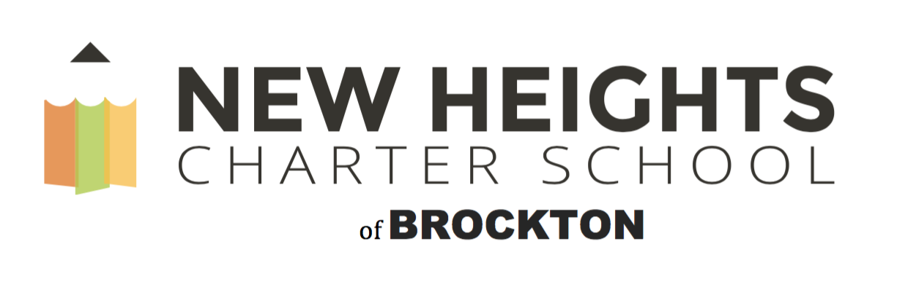
Wellness Policy
The staff of New Heights Charter School is committed to the belief that we all, staff and students, need to have access to healthy food choices in addition to physical activity and mental health support to be our best selves. A healthy lifestyle promotes better student attendance, which in turn fosters educational success. Increasing obesity rates among school age children, along with chronic diseases continue to challenge our student’s maximum academic potential. The purpose of New Heights Charter School Wellness Policy is to create a healthy school environment, where the healthy choice is the easy choice.
Health Advisory Council (HAC)
In accordance with the Massachusetts Legislatures “An Act Relative to School Nutrition” (M. G. L. c 111, s 222), New Heights Charter School has established a health Advisory Council (HAC), which consists of students, parents, members of the district, a Wellness Team and a Board of Directors member. The HAC will meet quarterly to set wellness goals and objectives for the school year and provide informational updates to parents, our Board of Directors and the community at large. The HAC will review district-wide wellness policies, research and develop new policies and recommend activities that promote student wellness. The HAC will present its recommendations and finding to the Board of Directors yearly.
The Health Advisory Council (HAC) is an essential component of a successful, comprehensive, coordinated school health program. The council’s collective knowledge, expertise, influence, and advocacy can be a powerful force in working with the school health program.
The council is intended to ensure that the New Heights Charter School has an established group of school staff and concerned community representatives to recommend, review and help implement school district policies addressing school nutrition, nutrition education, physical activity and related issues that affect student health. As an advisory body, the council can identify health and social problems related to the community's youth, develop viable solutions, and identify key resources.
HAC reports, as well as minutes of the meetings, including the names of attendees, shall be maintained and provided to the Department of Public Health or the Department of Elementary and Secondary education upon request.
New Heights Charter School of Brockton will assess our Wellness Policy at least once every three years on the extent to which the school is in compliance with our stated policy, in addition to the progress made in attaining the goals established by the HAC. These assessments will be made available to the public via the NHCSB website.
Wellness Policy Goals
- The food selections offered and the nutritional education provided will encourage and support life-long healthy eating behaviors.

- New Heights Charter School of Brockton will provide programs that support physical, social and emotional well-being of our students and our staff.

- New Heights Charter School of Brockton will provide a safe environment that supports academic success for all students.

Wellness Policy Procedures
The Massachusetts School Nutrition Regulation for Competitive Foods and Beverages, (105 CMR 225.000) is an initiative aimed at combating childhood obesity by offering staff & students foods and beverage choices that will enhance learning, contribute to healthy growth and development and promote lifelong healthy eating habits.
NHCSB is committed to ensuring that all foods and beverages available to students on the school campus (during the school day) support healthy eating. The foods and beverages sold and served outside of the school meal programs (i.e., “competitive” foods and beverages) will meet the USDA Smart Snacks in School nutrition standards, at a minimum. Smart Snacks aim to improve student health and well-being, increase consumption of healthful foods during the school day, and create an environment that reinforces the development of healthy eating habits.
Nutritional Guidelines and Standards for School Meals:
The Food Service Program will continue to follow the USDA requirements for the Federal School Meals Program and the School Meals Initiative for Healthy Children. In an effort to entice students to make better food choices, New Heights will work with our Food Service Vendor to create meals that are appealing, served in a clean environment, and meet all nutritional requirements established by local, state and federal regulations. A summary of the standards and information are available at:
http://www.fns.usda.gov/school-meals/nutrition-standards-school-meals
https://www.vrg.org/journal/schoollunch.htm
http://www.fns.usda.gov/healthierschoolday/tools-schools-smart-snacks.
Nutritional Beverages
Carbonated beverages without nutritional value will not be available for student purchase. Students will be given water, fruit juices or milk (fat free, or 1%) with their daily breakfast and lunches.
Nutritional Foods
- NHCSB will ensure that healthy snacks and foods are provided in the cafeteria and at in-school events. Snacks made available on school property will meet the Massachusetts Action for Healthy Kids Guidelines.

  - Increase the availability of appealing nutritious food and beverages while minimizing the availability of high caloric/low nutrient counterparts.

  - At least 50% of a la carte items must provide high nutritional value (100% fruit juice, skim and 1% milk, etc.). Foods of high nutritional value will naturally have a significant amount of at least one of the following: calcium, vitamin C, vitamin A, iron or fiber.

- Snacks may be brought from home for children’s own consumption, with the understanding that some classrooms may need to restrict some types of recess snacks due to specific allergies that classmates or staff may have, such as peanut allergies.

- Parents are encouraged to send healthy snacks that will provide the “fuel” for effective learning. Foods of high nutritional value will naturally have a significant amount of at least one of the following: calcium, vitamin C, vitamin A, iron or fiber.

- Parents are to refrain from sending snacks to be shared. This is because every school has children who have severe, life-threatening allergies of all kinds. No child shall be put at risk of having an allergic reaction to foods brought into school.

School Meals

- Reimbursable school meals will meet, at a minimum, the regulations of the Secretary of Agriculture pursuant to subsections (a) and (b) of section 10 of the Child Nutrition Act (ACT U.S.C. 1779) and sections 9(f) (l) and 17(a) of the Richard B. Russell National School Lunch Act (42 U.S.C. 1758(f) (l),1766(a), the USDA Nutritional Standards and the American Dietary Guidelines.

- Free and Reduced Meals: NHCSB will make every effort to eliminate any social stigma attached to students that are eligible for free/reduced school meals. Applications for free/reduced lunch are available in the registrar’s office at school.

- Menus - Will be prepared and foods will be served to incorporate variety, appeal, taste and safety to ensure high quality meals. Nutritional meal data is available upon request. Meal times and scheduling: lunch periods are scheduled as near the middle of the day as possible. Twenty to Thirty minutes per day will be provided to students for lunch time.

- Environment - Creative, innovative construction will be applied to minimize noise level within the eating area. The eating environment will be located such that there is convenient access to hand-washing facilities before meals. The food service area design will minimize the time students are waiting in line.

Health and Nutrition Education

Health education provides critical content for students to develop and demonstrate health-related knowledge, attitudes and practices. The health educational department will implement education based on the Massachusetts curriculum frameworks for Health and Physical Education into its grades 6-8 curriculum. NHCSB shall provide a comprehensive health education program for grade 6-8 students implemented by certified health teachers. Health teachers will be adequately prepared to teach nutrition education and will participate in regular professional development. This program will provide students the opportunity to understand and practice concepts and skills related to health promotion and disease prevention.
Physical Education
Physical education and regular physical activity is an integral part of the total education of students, which contributes to the physical development of the individual through promotion and appreciation of physical fitness.

- Physical Education will be taught by a physical education teacher and the curriculum is consistent with the Massachusetts State frameworks.

- All students in grades 6-8 will be offered physical education and will be
taught by certified physical education teachers.

- The Physical Education program will be designed to stress personal physical fitness and encourage healthy, active lifestyles. All students will participate in physical education in accordance with current state laws, regulations and district polices.

- Co-curricular physical activity programs, including fully inclusive intramural programs and physical activity clubs, will be made available to all students.

- A range of physical activities are offered to meet the needs, interests and abilities
of middle school students, including students with disabilities and students with
special health care needs.

- The district will assess and if needed and to the extent possible make needed improvement to after school programs.

- Information regarding activities held at the school, recreation departments, and the YMCA will be communicated to families to encourage participation by all members of the community.

Staff Wellness
Employees perform their best when they are healthy and optimal employee performance is necessary. NHCSB staff will be encouraged to model healthy behaviors and take advantage of the educational and physical activity programs offered.

