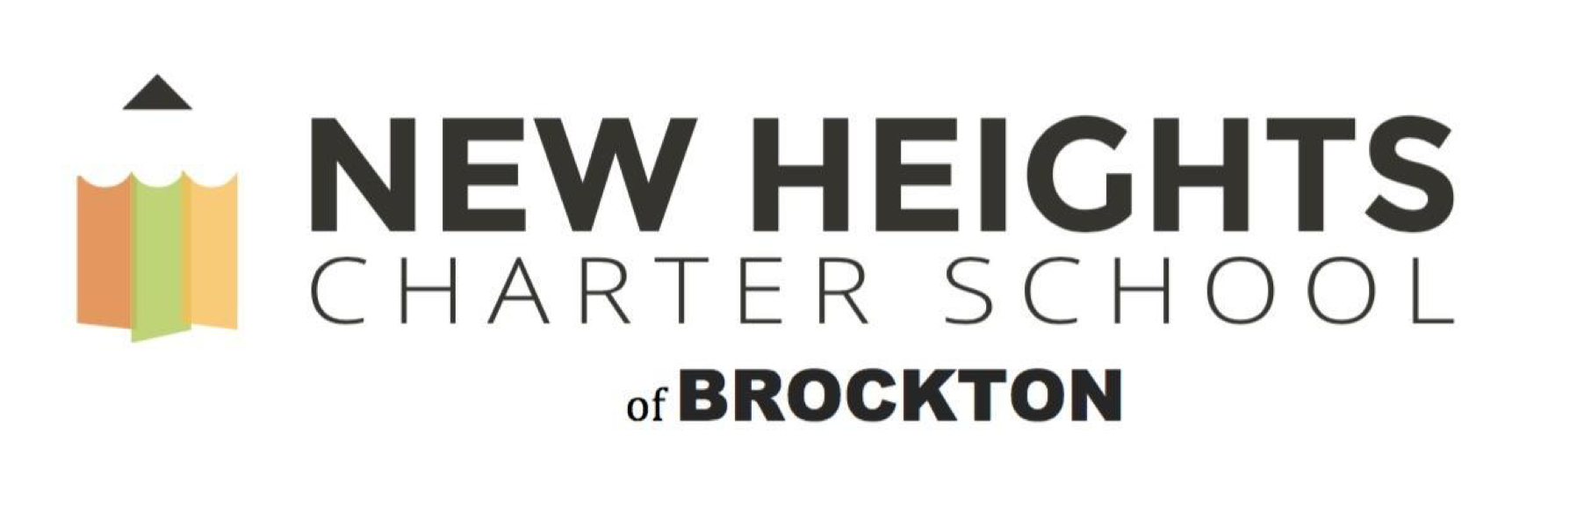

2018-2019
Annual Report

1690 Main Street
Brockton, MA 02301
Omari Walker
Executive Director
508-857-4633 (phone)
508-857-5721 (fax)
owalker@nhcsb.org
www.newheightscharterschool.com

Submitted August 1, 2019
Table of Contents
Introduction to the School 2
Letter from the Chair of the Board of Trustees Michael J. Sullivan 3
School Performance and Program Implementation 5
Faithfulness to Charter 5
Amendments to the Charter 10
Dissemination Efforts 14
Academic Program Success 16
Student Performance 16
Program Delivery 19
Organizational Viability 20
Organizational Structure of the School 20
Network Structure or Multiple Campus Organizational Structure 22
Teacher Evaluation 22
Budget and Finance 23
A. Unaudited FY19 statement of revenues, expenses, and changes in net assets (income statement) 23
B. Statement of net assets for FY19 (balance sheet) 24
C. Approved School Budget for FY20 25
D. Capital Plan for FY20 25
Additional Information 26
Accountability Plan Performance for 2018-2019 26
Recruitment and Retention Plan 26
School and Student Data 26
Additional Required Information 26
Anticipated Board Meeting Schedule for 2019-2020 27
Conditions 27
Complaints 27
Attachments (optional) 28
Appendix A 31
Accountability Plan Evidence 2018-2019 31
Appendix B 40
Recruitment Plan 40
Retention Plan 46
Appendix C 52
TEACHERS AND STAFF ATTRITION FOR THE 2018-2019 SCHOOL YEAR 54
BOARD AND COMMITTEE INFORMATION 54
BOARD MEMBERS FOR THE 2018-2019 SCHOOL YEAR 55
Appendix D 57
Accountability Plan Evidence 59
Attachments 59

Introduction to the School

New Heights Charter School of Brockton
Type of Charter  (Commonwealth or Horace Mann) | Commonwealth | Location of School (Municipality) | Brockton
Regional or Non-Regional | Regional | Chartered Districts in Region | Brockton, Randolph, and Taunton
Year Opened | 2016 | Year(s) the Charter was Renewed  (if applicable) | N/A
Maximum Enrollment | 735 | Enrollment as of July 7th, 2019 | 519
Chartered Grade Span | 6-12 | Current Grade Span | 6-10
Number of Instructional Days per School Year | 184 | Students on Waitlist as of August 1, 2019 | 157
School Hours | 7:40-4:00pm (M-Th)  7:40-1:00pm (Fri) | Age of School as of 2018-2019 School Year | 3
Mission Statement: To prepare every student for college. Period.

Letter from the Chair of the Board of Trustees Michael J. Sullivan

Dear Friends of the New Heights Community,

I write on behalf of the Board of Trustees of New Heights Charter School (“New Heights”) of Brockton to present an overview of the 2018-19 school year and publicly acknowledge the tremendous work done by our students, staff, and administrators. In addition, the Board would like to thank the tireless efforts of our families and our community for their endless energy and support of the New Heights’ mission and vision. We are very proud of the state of our school, three years in, and it is my pleasure to share with you a small sample of the many successes met at our school this year. Together, we are changing the world!

Students:
Every new school year begins with the arrival of 105 new 6th graders to join our student body. The 2018-19 school year saw a positive increase in the number of applications to our annual March lottery not only for new 6th grade seats, but also for vacated seats in grades 7-10. New Heights stands poised and ready for the start of the 2019-20 school year with a healthy waitlist. Our enrolled student demographics reflect an increasing geographical, cultural and ethnic diversity that we believe contributes to a strong learning environment.

Facilities:
During the 2018-19 school year, New Heights was finally able to enjoy our building without any major capital projects! Instead, the Board and school administrators worked to develop a strategic plan for the remaining years in the school’s development until, 2021, when New Heights reaches full enrollment with 735 students in grades 6-12. Plans for the 2019-20 school year include a new satellite campus for our students attending courses at Massasoit in addition to a few structural changes to accommodate a growing staff in place to meet the myriad needs of our students.

Finances and Development:
New Heights’ finances are strong, due in large part to the tireless work of the Board’s Finance Committee, Executive Director Omari Walker, and a new staff addition in Suzanne Graham, Business Manager.

Academic:
The Board is pleased to announce exciting news around New Heights’ academic model including our first year with high school students completing the PSATs, tenth grade MCAS, and college course completion. However, the biggest news to share is that 95% of 10th grade students earned college credit this year! In total, 696 college credits were earned during the 2018-19 school year, 681 college credits for 9-10th graders and 15 college credits for 8th graders. Not only do the college course work better prepare our students, those credits will save students and families approximately $145,000.

Families and Culture:
At New Heights it is common to hear our staff commenting that we have the best families ever. And the Board concurs. At our annual multicultural night, nearly 1000 members of the extended New Heights family ate, danced, and engaged in hands-on learning. New Heights’ believes in recognizing the hard work of our incredible scholars through quarterly honor roll breakfasts or ice cream socials. Our high school students were also recognized at a very well-attended award ceremony, where they were recognized for academic achievement in all content areas as well as character and college awards, the latter was given to students selected by the college faculty. Our middle school team hosted a beautiful graduation for our departing 8th graders, recognizing students for a number of special awards, include awards associated with our school values, H (Honesty) E (Empathy), I (Ingenuity), G (Grit), H (Humility), T (Teamwork), and S (Service) = HEIGHTS.

According to Charter Board Partners, a charter school board “focuses on student achievement, acts strategically, recruits and retains an exceptional school leader, raises and uses resources wisely, and fulfills all compliance expectations.” The New Heights Board of Trustees meets monthly in open meeting sessions to ensure that the Board meets these requirements in addition to receiving important financial, academic, and governance updates from New Heights staff. The Board is working to develop an academic dashboard to ensure transparency in academic data for all stakeholders as well as a strategic plan that builds upon the foundation developed by the state-approved accountability plan. At the conclusion of the 2018-19 school year, the Board, and myself acting as Chairman, certify that the state of New Heights is sound. We eagerly await the start of our fourth year in the fall of 2019. This work would be impossible without the vision of Executive Director Omari Walker and his stellar staff, our amazing and engaged families, and most important, our remarkable students.

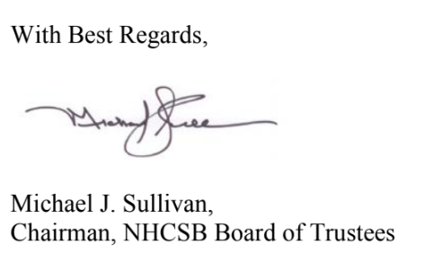

School Performance and Program Implementation

Faithfulness to Charter

Introduction to Key Design Elements:
The mission at New Heights Charter School of Brockton (NHCSB) is to prepare our students for college. Period. How does NHCSB intend to achieve this mission? We will use our three key design areas – our “We go to college” culture, our Fast Track Early College design, and our Professional and Community Development to create a strong foundation for our students and staff to reach our goals. Above all, each of us: staff, students, families alike, will focus on the idea that EVERY student will be prepared to attend and succeed in college. Our primary goal is to meet our mission to prepare students in college by enrolling them early in college courses, providing the support services they need to succeed, and creating an environment that is both nurturing and encouraging. The founding team, in collaboration with EDWorks, identified three key design areas that create the foundation upon which NHCSB is built. Design area one is our “We Go to College” culture. Design area two is the “Fast Track Early College Design”, a model designed by EDWorks. Design area three is “Professional and Community Development”. Each of these design elements weave through our lower school (grades 6-8) and our upper school (grades 9-12) daily routines including NHCSB’s’ curriculum, instructional model, professional development, school culture, and allow us to reach our mission of preparing our students for college.

Program Description:
In order to realize our mission, NHCSB opened in 2016 with 315 students spanning grades 6-8. After each academic year, we add a new 6th grade class until we reach capacity, in 2021, with 735 students in grades 6-12. NHCSB addresses the troublesome transitions between middle school, high school, and postsecondary education that prevent some students from successfully completing their education and entering the workforce prepared. Our students will enter NHCSB in the 6th grade, spending their first three years in our “Lower School”, grades 6-8, with a primary focus on developing the academic and social-emotional skills necessary to get into and succeed in college. Upper School students, grades 9-12, may begin taking college courses as soon as in the 9th grade and continue earning college credit towards a Liberal Arts Associate’s Degree at Massasoit. A student’s instructional day at NHCSB begins at 7:40 am, with breakfast in the classroom with an advisor, and ends at 4:00pm.

2018-19 School Year:

Key Design Element #1: We Go to College Culture
College culture continues to be a critical aspect of our school model, evident in the naming of advisories after the college Alma Maters of our faculty or schools the students have expressed interest in attending. During their advisory, students in all grades began working on college exploration, major selection and career interests on their Individualized Learning Plans, with high school students being the first to explore Naviance, a new platform to NHCSB that all students will utilize in the 2019-20 school year. In addition, NHCSB students continue to visit colleges throughout the school year. The 2018-19 year had our middle school students visiting Harvard, Benjamin Franklin Institute of Technology, and Lasell College. High school students completed a survey and attended schools that aligned to their future aspirations and wants in a college, attending trips to Tufts University, Stonehill, Bridgewater State University, UMass-Boston, Bentley University, and Framingham State University.

New to this year was the opportunity to delineate between our younger and older students and provide each with college knowledge appropriate to their grade level. Last year all students had quarterly electives, this year, middle school students had College Prerequisites. College prerequisites served multiple purposes and are designed to close the academic gaps our scholars come to us with as 6th graders because we want to ensure ALL NHCSB students will graduate with the essential soft skills needed to succeed in college. There is no opting out or electing out, these classes are a required part of the New Heights middle school curriculum, and grades do count. NHCSB students develop the 21st century skills necessary to be successful in high school, college, and beyond through the content covered in our four courses, Prep for Success, It’s LIT, College Readiness/MCAS Test Taking Skills and Practice, and Wellness.

Course | Prep for Success | It’s LIT | College Readiness | Wellness
Skills | 1. Study skills  2. Organization  3. Time Management  4. Test-Taking  5. ILPs | 1. How to work in Teams  2. Leadership  3. Conflict Resolution  4. Problem-Solving  5. Stress Management  6. Empathy  7. ILPs | 1. Learn about colleges, majors, minors  2. College essay writing  3. Interview Skills  4. ILPs | 1. BOKS Health Curriculum  2. Physical Education

New to the 2018-19 school year was a semester-long course for high school sophomores entitled Foundations of Leadership, an elective course designed by Achievement First, a high-performing charter organization. For long-term success beyond our walls, students need to master additional skills and mindsets while also learning to navigate the complex college application and enrollment process. Foundations of Leadership focuses on increasing student ownership of learning while helping students develop the future-oriented self focused on long-term goals and ambitions by focusing on two of the four college and career readiness keys as defined by David Conley: 1) Key Learning Skills & Techniques and, 2) Key Transition Knowledge and Skills. The course is grounded by 5 key program tenets:

- Cultivate a College Going Identity
- Take Ownership of Learning for High School, College and Life Success Practice and Internalize:
- Develop College to Career Connection and Long-Term Vision
- Become Critical Consumers of Post-Secondary Options
- Navigate the Complex Application and Matriculation Process
- Learn Personal Finance Skills and the Ability to Navigate Financial Aid

Throughout the semester, students utilized Naviance to support and enhance their self-exploration, learning, and future planning. Students researched their dream career and put on a fair for the younger students in the building; they attended networking events, participated in mock interviews, created their resumes, worked on their time management, and practiced email communication and etiquette. Many of our high school students cited the course as being incredibly helpful in securing their summer employment.

Key Design Element #2: Early College Design
The 2018-19 school year proved to be an important year for our unique early college design. Early College design requires a school culture that enhances academic preparation, particularly with literacy and numeracy, whilst promoting college awareness and readiness skills inherent to a student’s success in college. In the middle school, all students had an intervention period during the day, which took place three times a week. The purpose of Grit, Grapple, and Grow was to provide our students the space and time to receive the additional support needed in order to fill in any gaps in learning that they may have. During the intervention period, our students have the opportunity to work on ALEKS, which is an online individualized math program that is also used by our College partner, Massasoit Community College, or work on LEXIA Power Up, which is an individualized computer literacy program designed to get students caught up to grade level in reading comprehension. In addition to these two individualized computer programs, teachers use flexible grouping to create small groups and facilitate small group instruction that is customized to students’ individual needs. Lastly, we have tutors who go around to different intervention classes at this time and pull students to do small group instruction. The high school also had designated intervention blocks, on Tuesdays and Thursdays, where students could opt into specialized workshops, study sessions, or peer tutoring, as a means to enhance their academics and their ability to self-elect, reinforcing autonomy and self-efficacy. Students who were not passing classes had mandatory academic supports; however, the subject area with which they wanted support in was their decision on a weekly basis.

All 9th grade students are first enrolled in ENGL 095, which is the college developmental course co- designed by New Heights and our college partner MCC. The course is considered to be the “gatekeeper” for our students in that they must successfully pass the course with a C- or higher in order to enroll in Composition I in the fall of their 10th grade year. Students who do not pass will enroll in Massasoit’s 099 course, which provides students another opportunity to hone and strengthen their reading and writing skills prior to enrolling into a college credit-bearing course.
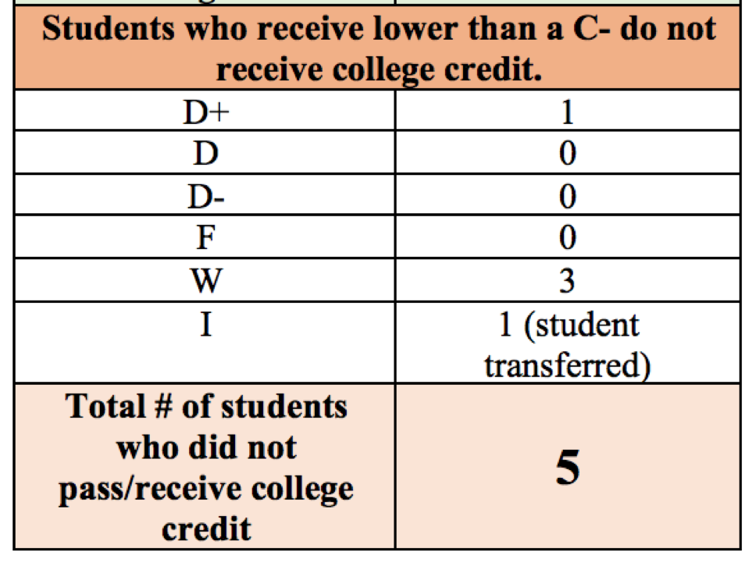
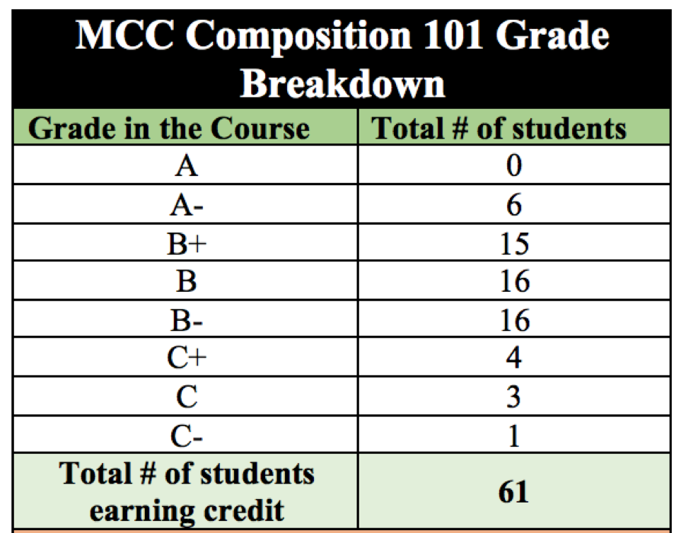
At the beginning of the school year, 66 of 92 10th grade students were enrolled in MCC’s Composition I as a result of their performance in 095 and their writing samples. At the end of the first semester, of the 66 students initially enrolled in the course, 61 passed with a C- or higher and earned 3 college credits. (See table to the right for further breakdown.)

Additionally, our 099 students showed immense growth within their reading and writing during the first semester, and MCC suggested students enroll in the credit-bearing Public Speaking course in the spring. This addition afforded 98% of our 10th grade students the opportunity to enroll in a credit-bearing college course during the 2018-19 school year. It also impacted and altered our initial scope and sequence moving forward. At the beginning of their 10th grade year, students can begin the college pathway and are eligible to take English courses with college professors from Massasoit Community College. As an additional measure to assess and assure that our students’ are ready for the demands of collegiate writing, at the end of this year we introduced an additional requirement that we also have our students take placement tests in Reading and Writing, as they have done in Math. Our 10th grade students who place in college courses will be able to enroll in one of two courses during Fall 2019. Public Speaking will take place at New Heights with a professor from MCC. During this course, students will analyze informative and persuasive techniques and research, organize, and deliver a minimum of three formal speeches: two of which must be informative, and then a final persuasive speech. Higher placement will allow some of our 10th graders the opportunity to enroll as full-time college students at MCC and begin by taking Composition 101.

We continue to provide differentiation and opportunities within math course offerings. During the 2018-19 school year, we had our students enrolled in: College Algebra, Pre-Calculus, and Calculus college courses in addition to their high school required math course. We are incredibly proud of the work our students completed this year, and our progress with our early college programming. As of the end of 2018-19, NHCSB had
- 98% of 10th graders had the opportunity to enroll in a college, credit-bearing course in the 2018-19 school year.
- 93% of the 10th graders have earned at least 3 college credits at the end of the 2018-19 school year.
- 69% of 10th graders have earned at least 6 college credits (two college courses)
- 29% of 10th graders have earned 9 or more college credits (three college courses)
- 20% of 10th graders have earned 13 college credits (four college courses)
- In total, NHCSB students have earned a collective total of 596 college credits at the end of the 2018-19 school year.
- 12 9th grade students have earned 3 or more college credits at the end of the 2018-19 school year (a year ahead of schedule.) Of those 12, 4 students have earned 7 credits (2 college courses,) and 4 students have earned 11 credits (3 college courses.)
- 5 8th grade students completed the Math Developmental course sequence during the fall. Students took the ACCUPLACER math exam along with 9th and 10th grade students, and they placed into College Algebra for the spring. 100% of those students passed the college course.

Key Design Element #3: Professional and Community Development
NHCSB continues to provide and host workshops and events to strengthen our parent and community partnerships. Our yearly Multicultural Night, which doubled in attendance from the 2017-18 school year from 400 to 800, continues to be an evening celebrating the rich diversity of our families’ cultures. Throughout the year, families are invited to attend honor roll breakfasts, award ceremonies, and athletic banquets to honor their student’s achievements. Additionally, the middle school hosted monthly parent meetings to address issues, concerns, or topics relevant to their student. The high school’s meetings focused more on the early college aspect of our school; topics ranged from: college credits, high school transcripts, financial aid/literacy, and other components of the school’s curricular design. In this third year, NHCSB had students who were of age to take advantage of the growing partnership with YouthWorks and MassHire. Our older students attended workshops on professionalism, email etiquette, resume building, and interviewing skills; students also went to several networking events with local businesses and companies. We are continuing to forge our relationships with our sending districts of Brockton, Randolph, and Taunton to provide mutual benefits and the sharing of resources for all students.

Finally, NHCSB staff benefited from professional development both after-school school Fridays (including guest speakers on instruction, classroom management, inclusive classroom design, and targeted content area work) as well as our annual August retreat (week-long PD) and January PD (1 day) and additional weekly meetings between coach and teacher or content-area teams to work on student-level data, classroom design, and instructional support. This year focused on the honing and improvement of our coaching and professional development cycle.

NHCSB Coaching Model
The Purpose
While it is tied to the coaching model at NHCSB, instructional coaching is not strictly about teacher growth and performance. We focus on students because the true function of instructional coaches are to help close the opportunity gap and accelerate student learning. An exciting bi-product of pursuing this mission, is that coaches get to help teachers become their best selves.

Below is an outline of everyone’s role within the coaching model. One role we all play within this model is the role of a CONTINUOUS LEARNER. As a community of continuous learners within the coaching model, we must…
- Own everybody’s successes and failures and reflect upon them
- Explore, implement, and reflect upon new best practices
The Role of the COACH
Just like teachers, coaches have many functions. Below outlines, in order of frequency, exactly what teachers should expect from their coaches.

1. Classroom Data Collectors: your coach’s goal is to be an agent of change regarding student learning-- because all of the students' time is spent in a classroom, that is where you can expect to see coaches. As a coach in the classroom, you will...
  - Video student performance
  - Collect holistic student data
  - Support teachers (periodically modeling/co-teaching)
  - Communicate observation data/feedback to teachers and schedule a reflection conversation (in a timely fashion)
2. Data Miners: aside from classroom level data collection, coaches are also tasked with examining and mining through district, state, national, and global data (i.e. MAP and MCAS testing, Dean’s List Data, PowerSchool/Gradebook Data, Survey data, DOE data, etc.) As a data miner, you will...
  - Analyze trends that influence PD + coaching
  - Create data displays
  - Run data reports for state publishing
  - Compile lists of students for RTI, tutoring, other academic interventions/conversations
3. Collaborators: coaches can also function as a sounding board for planning and/or best practices-- bring them all the questions you have, but be prepared to be met with more questions rather than ready made resources. As a collaborator, you will...
  - Coach teachers through finding and building resources
  - Facilitate conversations about content/lesson planning
  - Coach teachers through strong assessment design
  - Discuss feedback on lesson maps, materials, objective calendars, etc.
4. PD Facilitators: coaches often create professional develop for the entire school and district in order to better support student learning. As a PD facilitator, you will design and facilitate the follow...
  - Instructional PD (grade level, content, cross-content)
  - Looking at Student Work PD
  - Team Building PD
5. Curriculum Writers: a coach’s goal is to seamlessly integrate mastery driven curriculum that is grounded in the state standards and is aligned with our mission. As a curriculum writer, you will...
  - Write year-long Curriculum Maps for and unpack it with teachers
  - Create and facilitate curriculum surveys (teachers and students)
  - Discuss curriculum glows/grows at the close of each unit
6. Formative Teaching Evaluation: your coach with perform 2 formal observations per semester in order to gauge our progress toward meeting intended school goals (i.e. Q1: Classroom Culture, Q2: Academic Rigor, Q3: Instructional Practice, Q4: Assessment)
7. Summative Teaching Evaluation: your coach will perform 2 Summative Evaluation professionalism, planning/coaching interactions, parent contact, surveys, formal/informal observations.

The Role of the PRINCIPAL
- Communicator: To build understanding of the interconnectedness of the coaching model, school improvement plans, and district initiatives including but not limited to:
  - Articulating the purpose and components of the coaching model to staff
  - Leading and communicating to staff about the district and building initiatives in relation to the coaching model
  - Maintaining the fidelity of the Instructional Coaching Model
- Facilitator Purpose: To collaboratively plan and coordinate professional learning including but not limited to:
  - Fostering a safe and trusting environment
  - Aligning professional learning with the building’s SIP (School Improvement Plan)
  - Facilitating access to the coaching model process
- Leader Purpose: To support coaches and teachers in the coaching model including but not limited to:
  - Implementing the school and district initiatives
  - Meeting with school coaches and leadership team on a regular basis to examine school data and assist in school‐wide planning (including professional learning) Acting as a strong advocate for student learning based on data used to inform instruction
  - Sharing best practices research
  - Committing to meet regularly with coach or coaches to support their roles
- Learner Purpose: To promote and model professional learning including but not limited to: Engaging in professional reading and learning opportunities, and participating actively in the teaching and learning cycle
- Evaluator The Principal is responsible for evaluating the coach.
The Role of the TEACHER
1. Instructor: as a teacher your primary role is served in the classroom providing instruction to prepare students for college. As an instructor within the coaching model, you...
  - Reflect and refine instruction based on coaching
  - Collecting and reflecting upon individual student data
  - Reflect and refine practices in order to teach all students

2. Collaborators: teachers also function as collaborates with coaches and peers. As a collaborator within the coaching model, you...
  - Come prepared to coaching meetings
  - Actively and genuinely participate in coaching conversations
  - Assume best intentions

Professional Development at NHCSB
What | When
Friday Instructional PD  Every Friday our students are dismissed at 12:45, so we can meet as a team for PD. We will host school-based PD every other Friday. Periodically, we may have pre-work for PD to ensure we are prepared and can maximize our time. Given the varying needs and goals of our staff, we have differentiated PD for our staff and teachers. This allows for teachers to attend sessions relevant to their current teaching practice rather in a smaller group. | Friday @ 1:45  Bi-Monthly
District PD  Once a month, we will meet as an entire district (middle + high school) for PD. These PDs tend to focus more on instructional technology (ie. how to utilize Google Drive or other gradebook functionality) or operational necessities (ie. lock down procedure. ALICE training, human resources updates.) | Friday @ 1:45  Once a Month
Instructional Coaching  Coaching meetings will occur during the week on a prep period selected by the teacher. If teachers want to meet outside of their scheduled coaching time, that’s great! Outside the Instructional Coaching office, the coach’s availability will be posted and they will host office hours where they are available for unscheduled, quick meetings/conversations. | Once a Week (or more if teacher or coach requests)  Teacher + Coaches  Decide Together

Amendments to the Charter
Board approved (major) or Commissioner approved (minor) amendments requested by the school’s board of trustees during the 2018-2019 school year. Please explain any delay in implementing any recently granted amendment.

Date | Amendment Requested | Pending or Approved?
June 22, 2018 | Schedule Amendment | Pending Commissioner Approval
June 11, 2019 | Approval of New Board Member | Approved
November 21, 2018 | Approval of New Board Members | Approved

Access and Equity: Discipline Data
Most recent, publicly available student discipline data for New Heights Charter School of Brockton: http://profiles.doe.mass.edu/ssdr/default.aspx?orgcode=35130000&orgtypecode=5&=35130000&
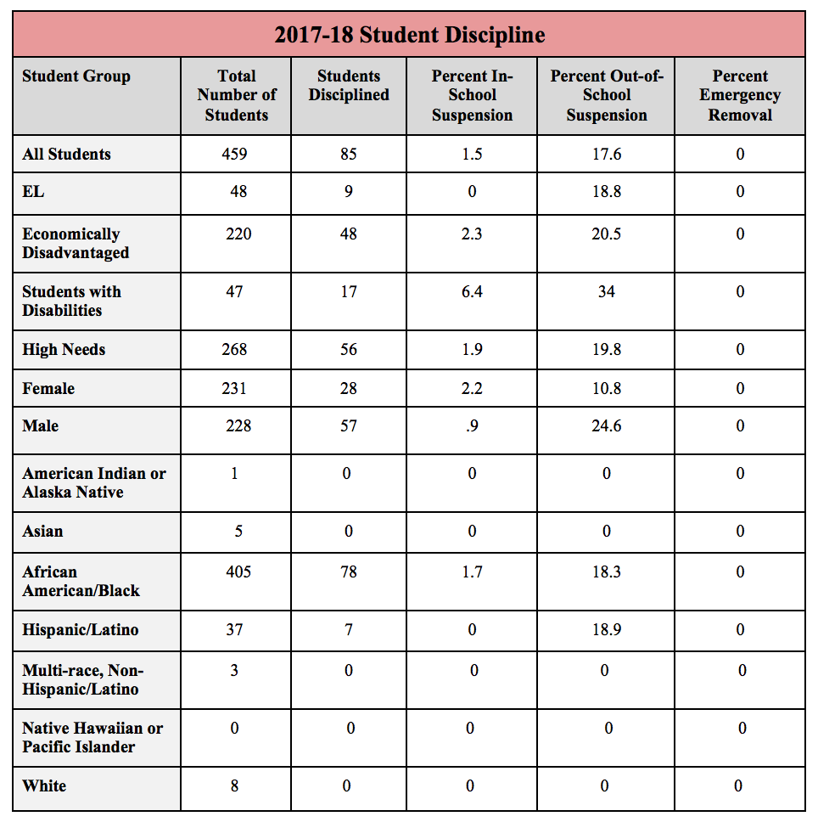

This Year: 2018-19
During the summer of 2018, both middle and high school leadership teams reviewed the prior year’s disciplinary data along with parent, student, and teacher feedback in order to revise the behavioral expectations, systems, and policies with the overarching goal to lower our suspension rate, increase all students’ time on learning, increase positive school culture, and increase community morale through increased opportunities for restorative justice actions. Summer professional development provided staff with restorative justice workshops and instructional PD on effective and engaging lessons. Below describes several key changes introduced this year and outlines next steps for the 2019-20.

Middle School:
- Revised Merit System: The Merit System is a way to teach positive and appropriate behavior through immediate, consistent feedback and positive reinforcement. This school-wide behavioral system recognizes and rewards students who are following expectations, setting a positive example for others, and exemplifying our HEIGHTS core values. In SY18-19, students could earn a different level of merit based on the positive act or deed. When students go above and beyond the expectation, they may earn Silver Merits (+3) and/or Gold Merits (+5). Merits give students access to weekly, monthly, and quarterly incentives/rewards as well as other field trips and school-wide events. See example of the varying merits below:
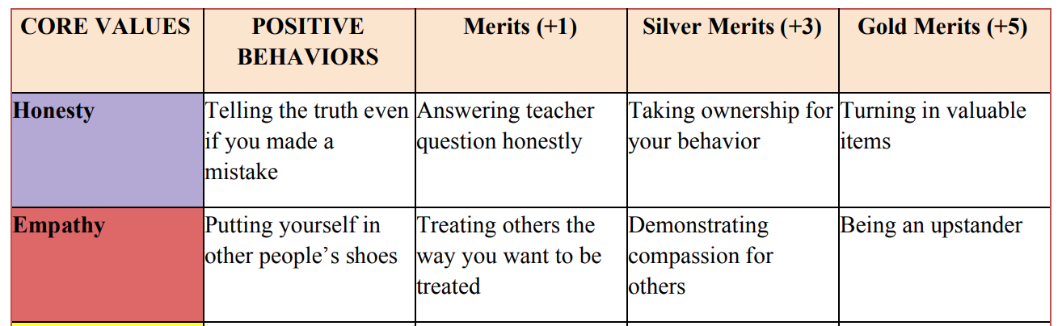
Additionally, in an effort to incorporate more of the human element and component into the system, the demerits were simplified from the year prior, and the process altered so as to diminish the punitive feel. When students are not following expectations, teachers or administrators first give students a verbal warning/reminder rather than immediately assigning a demerit. If the student continues with the undesired and/or inappropriate behavior after a warning has been given, then a demerit will be issued. This type of consistent feedback allows students to reflect on their behavior, learn from it, and make better choices next time. Demerits are designed to meet the particular level and severity of the inappropriate behavior.
- Keepin’ It Real Circles: Keepin’ it Real is New Heights’ interpretation of a Restorative Justice Community Building Circles; during this time, we are open and honest with one another about our thoughts and feelings and that we openly discuss important and meaningful issues in our community in order to make things better. Keepin’ it Real Circles are a weekly activity built into advisory, and they may serve as a students’ consequence in lieu of detention or suspension.

High School:
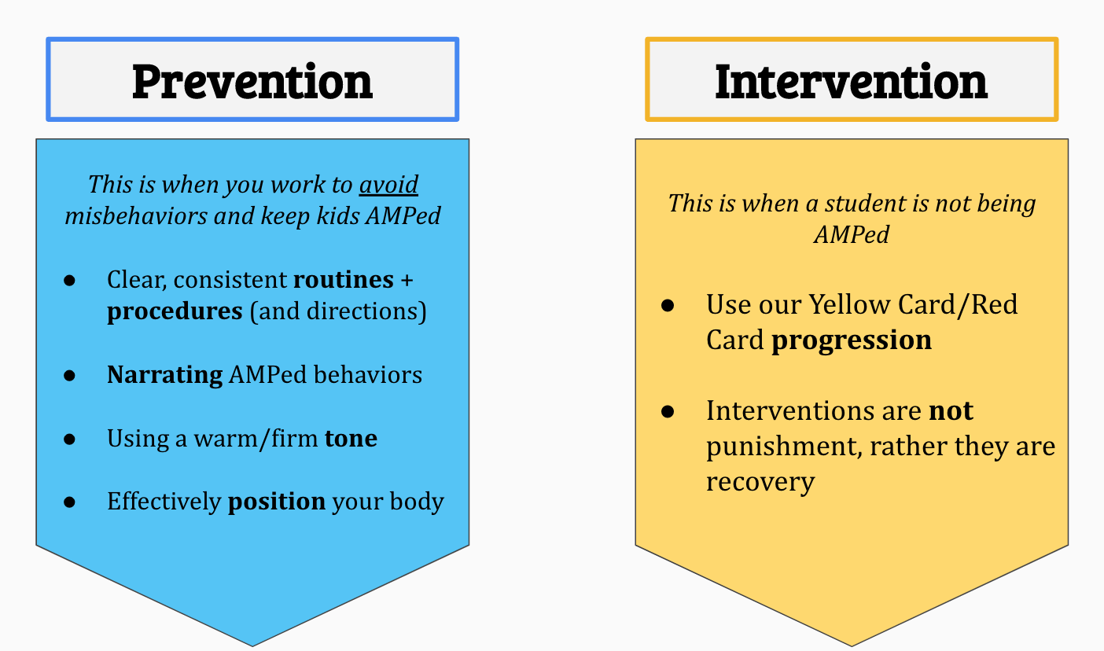
- New Code of Conduct: Taking into consideration the developmental stages of high school students, the HS introduced a Code of Conduct that focused on the idea that a successful student is an AMPed student, which is a student who is Attentive, Mindful, and Prepared. We focused on what students should do rather than what they shouldn’t. Additionally, the HS did not utilize a merit system; instead, opted for a progression of behavior interventions that allowed for student voice and opportunity to reset and re enter the classroom. Wanting to instill a team mentality, the progression utilized the yellow and red card system of soccer. UnAMPed behavior earns a student a yellow or red card, which is, like in soccer, a temporary removal from the classroom (or field.) And it also signals the teacher to reflect on his/her own responsibility in the unAMPed behavior.

The student is still an important part of the team; he/she just isn’t in the right mind space to be engaged in the classroom. And the card affords the student the ability to talk with another adult to check in and further unpack the motivations and rationales behind the behavior. Students need to know that they belong in the classroom, that teachers want them in the classroom, that it’s okay to have a bad day, and that we are here to support their growth as students and human beings.
Moving Forward into 19-20:
While the 2018-19 disciplinary data has improved since 2016-17 and 2017-18, the leadership team plans to revise and rethink the elements of the behavior management systems to continue to improve student culture and reduce suspensions. There are a few critical components integral in this shift that are discussed below.

- Rethinking Discipline Action Plan: With the support from DESE, this spring, the NHCSB leadership team, spearheaded by the principal and deans, analyzed student discipline data from the past two years to create an action plan that improves discipline disparities through programmatic changes to address concerns. Below is an excerpt from the plan that provides a brief analysis of the data and root causes.
NHCSB Discipline Data Analysis
SY 2017-2018
The difference between our 2017-2018 removal rate for students with disabilities (SWD) and the school removal rate is 17.7%, which is greater than the 2 standard deviation threshold (14.7). Additionally, the difference between the removal rate for SWD students and the state removal rate is 32%, which is greater than the 2 standard deviation threshold (27.7%). Lastly, the school removal rate 18.5% is greater than the state average school rate (6.7%). After analyzing this data, we have concluded that we need to reduce the use of suspension and expulsion for students with disabilities by determining alternatives and restorative approaches to disciplinary consequences. In other words, we must reduce the need for reliance on suspension and expulsion as a response to misconduct. Instead, we must explore other alternatives to exclusionary consequences and practices as well as standardize interventions that address the root of the behavior and support students in developing more positive, pro-social responsible behaviors.
Root Causes of Problem of Practice (Disproportionate Use of Suspensions/Expulsions)
- Failure to standardize interventions that address the root of the behavior and support students in developing more positive, pro-social responsible behaviors
- Failure to provide teachers with a “Teacher Behavior Prevention Toolbox” filled with interventions and other best practices that teachers can utilize to engage in a strategic set of actions/steps to re-engage students at the first signs of behaving unskillfully or inappropriately.
- Additionally, we failed to provide teachers with targeted practice sessions/opportunities and coaching around how to implement these “Teacher Behavior Prevention Toolbox” strategies and interventions
- Merit/Demerit system which led to teachers relying ONLY on the demerit component of this system to address behaviors. Teachers developed the false notion that demerits are the only tool to address unskillful/inappropriate behaviors.
- Merit/Demerit system which led to teachers becoming “referees” who only looked to call “fouls”. Teachers defaulted to looking for students doing things wrong, rather than looking to catch students doing GOOD. Consequently, positive, pro-social behaviors were not being positively and consistently reinforced. This led to the development of a negative school climate and culture. Students began checking out and not wanting to participate in the Merit System because they felt they were only being caught doing “bad” or “wrong” and not given enough opportunities to be caught doing GOOD.

- Additional Positions in SY19-20:
  - Dean of Data and Accountability: This new position will be instrumental in providing the principal and deans of students with discipline data and trends to allow for necessary shifts and changes to eliminate disparities.
  - School Psychologist: The past three years NHCSB has outsourced counseling services, and it proved to be challenging to accommodate an outside provider with varying hours and schedules. The growing need for these services for our students resulted in the addition of a school-based psychologist in the 2019-20 school year.
- Resiliency Program: Geared towards our MS students who have accrued the highest number of suspensions and referrals based on the 2018-19 PowerSchool and Dean’s List data, the goal of the Resiliency Program is to provide students with a smaller, more individualized and supportive environment to enhance their academic and social readiness and needs. The program is managed by a certified special education teacher who has a history of managing self contained classrooms, and extensive knowledge of PBIS systems. Our lead teachers will rotate through the program, owning and teaching their content to RP students. Their schedule is altered slightly to provide students with additional academic and social supports, such as: reading intervention, study hall, group counseling, and an extended recess period. The program is highly incentivize through PBIS with students having the opportunity to earn daily, weekly, and monthly incentives. Additionally, students will participate in overnight retreats with staff that are geared towards team building and leadership skills.

Dissemination Efforts

Best Practice Shared | Vehicle for Dissemination | Who at the school was involved with the dissemination efforts? (Title) | With whom | Result of dissemination
Illustrative Mathematics Curriculum | Two day in-person summer professional development (August 2018), schools visits, and virtual PDs/check ins throughout the 2018-19 school year. | Dean of STEM (6-8), Arielle Zern, and Dean of STEM (9-12), Tami Dashley Shah, and all NHCSB math teachers | Attleboro School District and Franklin School District. | Middle schools teachers were able to share materials, strategies, and best practices throughout the year. HS teachers participated in continued virtual PD to unpack the units, materials, and assessments given the HS Illustrative curriculum was in beta-testing/piloting.
College Readiness & Early College Programming and Partnerships | Presented and spoke in break out session entitled Finding Their Way: A Unique Early College Partnership at the Annual American Association of Community Colleges | Associate Provost of Massasoit Community College, Deanna Yameen & Director of College Access, Jess Geier | Targeted audience for participation included vice, associate vice, and assistant vice presidents who were in attendance at the 2 day conference in Orlando, FL. | Explore the unique design components of an innovative partnership between a middle/high school and a community college including academic, social/ emotional, and motivational success strategies to improve college preparation and success. In addition, Deanna and Jess shared how our two institutions partnered to create this exciting model.
High School and College Partnerships and Curriculum | Participated in an early college podcast, https://podcasts.apple.com/us/podcast/community-college-voice-podcast/id1385048881#episodeGuid=a5d97065f093492681aa4caf666677df. | Associate Provost of Massasoit Community College, Deanna Yameen & Director of College Access, Jess Geier | Targeted audience is anyone working on postsecondary/higher education pathway development and policy work. | The podcast delved into the unique programmatic design of New Heights, our partnership with Massasoit, and key policy issues that shape the conversation on early college.
Early College Programming | RTI International Early College Conference in North Carolina, June 4-5th | NHCSB admin:  Executive Director, Asst. Executive Director, Director of College Access, Director of Curriculum & Instruction, and  Director of Early College and Post-Secondary Pathways | NHCSB was the only MA team present, however upon our return, we share the conference proposal with the new statewide Director of Early College as well as other members of the “early college designee” group who were looking for specific answers. The NC Team is planning a trip to MA over the summer/early fall to visit our program | This two-day event for school teams focused on current research, Early College best practices, and networking with peers. In addition, school teams had the opportunity for collaboration around implementation planning supported by the facilitation of project management tools. The Early College Summit is designed to support veteran and new early college teams as they consider strategies to emerge as next generation Early Colleges.
Early College Programming: College Partnerships & Course Sequencing/Selection | Middle College National Consortium (MCNC) Conferences (Both in February & June) | Executive Director, Asst. Executive Director, Principal, Director of College Access, Director of Curriculum & Instruction, Director of Early College and Post-Secondary Pathways, and Academic Deans. | February Conference was held in Newport Beach, CA, and the June conference was held in New Jersey. Both conferences are for MCNC members (school districts and personnel, and college partners.) | Middle College National Consortium is an organization approximately 40 public schools on college campuses across the nation. It is composed of Middle and Early College high schools (which are high school /college partnerships), and school districts in 16 states committed to preparing students in underserved communities for college by giving them rigorous coursework that will lead to college credits while students are still enrolled in high school. MCNC schools include both public and charter institutions that serve grades 7-12, 9-12, or 11-12. NHCSB spent ample time discussing and sharing programming and partnership specifics with members from the University of Alaska and Rhode Island.
Advisory/ MYCAP curriculum & sequencing | Massachusetts College and Career Advising Professional Development Series | Director of College Access, HS Principal, Guidance Counselor, HS teacher and advisor. | Early College & Innovation Pathway Designees, school districts throughout the Commonwealth | Workshop 1 • This introductory workshop will explore the nature and promise of CCA and MyCAP  Workshop 2 • This workshop will focus on the design of a grade level scope and sequence of CCA lessons  Workshop 3 • This workshop will support the successful design, implementation, and evaluation of your district/school’s CCA and MyCAP program
College to Career Connection (Job Exploration, Internships, Financial Literacy) | Connecting Activities | HS Principal, HS Teacher/Advisor, Connecting Activities Coordinator  YouthWorks/Brockton Area Workforce Investment Board | The Connecting Activities Coordinator, Director of Youth Services and partnering School Liaisons from Southeastern Regional School District, Brockton, Stoughton, Bridgewater, and Avon. | Please see the Monthly Meeting Calendar and the FY19 Connecting Activities and Programming Guide in the appendices.
Early College programming and experiences (from students’ perspectives) | MassINC on Thursday, June 6th  to Celebrate the Success of Early College High Schools and  Increase Awareness on Beacon Hill | NHCSB Executive Director, Asst. Executive Director, Dean of Humanities, and several high school students | Representatives and key stakeholders from early college schools and programs throughout the state as well as policy makers and local politicians and representatives. | Several presentations covering the following topics:  - Learn About Education Policymaking and Legislative Advocacy  - Share Your Early College Experiences with State Legislators  - Attend a Public Forum on Early College at the State House  Remarks from Massachusetts Commissioner of Elementary and Secondary Education Jeff Riley followed by a panel of students and educators representing early college high schools from across the state.

Academic Program Success

Student Performance
A. NHCSB 2018 publicly available student performance data: http://reportcards.doe.mass.edu/2018/DistrictReportcard/35130000

B. Below has the data and information from NHCSB report card and statewide Accountability Report.

Overall Classification | Accountability Percentile | Progress Toward Improvement Targets
2018 | 2018 | 2018
Not requiring assistance  Reason for classification:  New Heights Partially Meets Targets | 54 Percentile | Meeting 54 percent of improvement targets

C. In addition to the required and aligned MCAS assessments, NHCSB students participate in several internal and external assessments in order to inform our instruction, determine college readiness and placement, and ensure alignment between our secondary curriculum to the demands of college courses. Below is a table detailing the assessments students take throughout the year. It is important to note that the table does not reflect MCAS as well as content-level assessments (ie. semester exams and college finals.)
2018-19 NHCSB Assessments Administered
What | When
NWEA MAP Testing  At New Heights, our district uses NWEA MAP testing to diagnose, track, and assess student literacy and numeracy from grades 6-12. MAP testing does not count as a grade for a class, rather it functions as an integral data point for us as educators and for students. MAP testing not only comes with a teacher portal, it also allows students to see their results and self-assess/select the standards and skills their would like to sharpen. MAP testing also helps students set their own goals on the Individual Learning Plan in Naviance. | Diagnostic: September 31, 2018  Mid-Year: January 19, 2019  Final Assessment: June 14, 2019
Accuplacer: Math, Reading, and Writing  MCC uses the Math and ELA Accuplacer to gauge students’ readiness for certain college courses. All students at NHCSB will take both accuplacer tests at some point; however, given how varied our students readiness is, students will likely take the tests at different times. | Math: Dec/Mid-Year <or> End-of-Year  ELA: TBA-- varies depending on grade in 095/ELA9
PSATs  PSAT/NMSQT® emphasizes the skills that enhance careers, including problem solving in science, social science, and other real-world context. 9th and 10th grade students will have the opportunity to take this exam during the school day. | February 28th, 2018  Both 9th and 10th grade

NWEA MAP Data:
This year was the first year with our students taking the NWEA MAP Growth assessment in all core content areas, providing the school with its year one of baseline data. In the coming years, this data will become an integral component in the measuring of student growth and achievement. Not only we will be able to compare our students’ progress year over year, but we will be able to compare our students to students across the nation. Moreover, it’s growth projection summaries built into the platform provides key insights regarding a student’s anticipated performance on state and national assessments.

In the 2018-19 school year, data was utilized primarily within the school and classroom level. Administrators analyzed the data to assign students to interventions and set academic foci and initiatives in areas of higher need; teachers used the data to create strategic small groups, assign extension or “challenge” work to ensure all students were receiving rigorous coursework, and provide remediation on foundational skills; students utilized the goal setting report to set achievable goals for their performance in a given class, and they researched average RIT scores for colleges of their interest to see how they currently compare.

Below is a sample grade level report from the 2018-19 school year that details the 9th grader’s performance in reading.
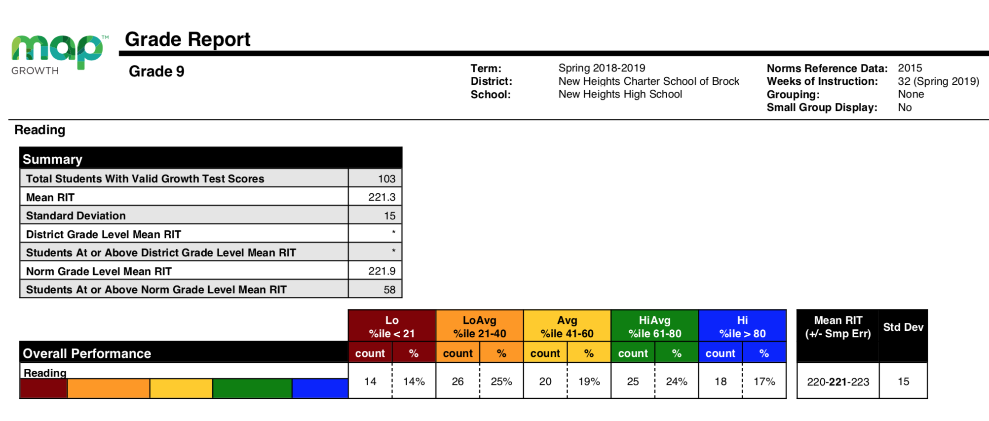
The report groups the students into 5 different categories based on their performance: low, low average, average, high average, and high. It also provides a “norm grade level Mean RIT” score as a point of reference and comparison of NHCSB 9th students to all 9th grade students across the nation. As of the spring, NHCSB 9th graders were .6 RIT points lower than the norm, and about 62% performed on or above average in reading. In 19-20 the instructional leadership team plans to utilize this data alongside MCAS, Accuplacer, and PSAT/SATs to inform curricular and instructional decisions and set yearly district and grade level goals.

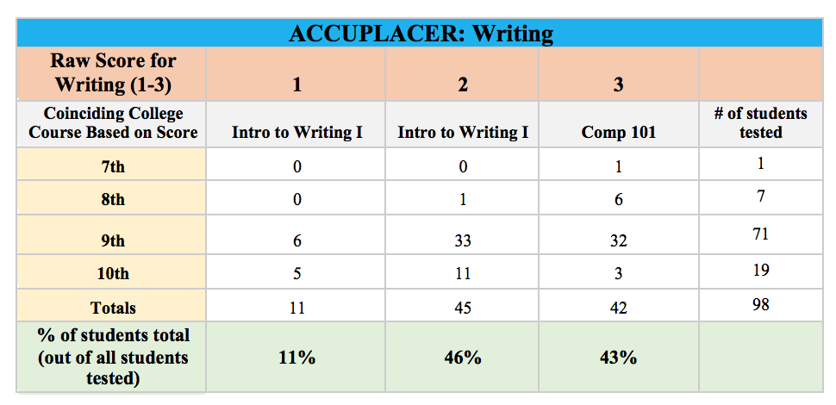
Accuplacer Data:

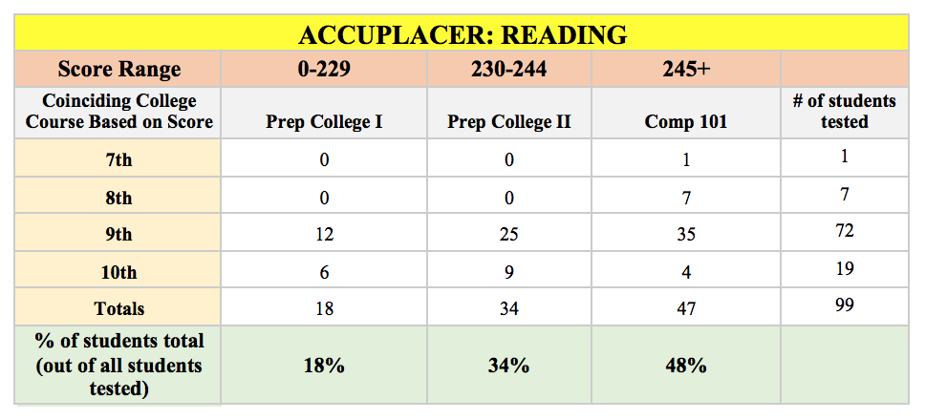
This year was our first year with the Accuplacer in reading and writing as an additional measure to assess and assure that our students’ are ready for the demands of collegiate humanities courses. It is important to note that there is no “passing” or “failing” of the test; the Accuplacer is a placement test and gauges what course a student is currently prepared for. If a student does not place into the college, credit-bearing course their first time, it simply means we need more time to adequately prepare him/her. It should be viewed as a “not yet,” rather than a “not at all.” A student’s readiness for the academic demands of college is of the utmost importance; a failing grade or withdrawal from a college course can impact a student’s financial aid eligibility as well as the student’s self-confidence. While we do not currently have a comparison point, the data below will serve as foundational data to compare future years’ data, inform our instructional foci in our high school courses, and help determine a student’s placement in ENGL 099, Public Speaking, or Composition 101 in the fall of next year.

Program Delivery
Year 3’s focus as a district centered around the elevation and refinement of current and established processes and practices within the school’s program. As a data-informed school, the leadership team requires ample data and evidence and the use of that data in any decision-making. Therefore, much of the program delivery changes that occurred in 2018-19 reflect the leadership team’s responses to financial restraints, stakeholder feedback, and school needs, and fall primarily into three categories: Summer Bridge, Assessment Methods, and the Instructional Model.

Summer Bridge:
During the past two summers, we have had our rising 9th and 10th graders participate in a three-week Summer Bridge Program in the month of July. Students engaged in “hands-on” learning projects for two weeks at New Heights, and the third week would culminate in a larger initiative or experience taking place on the college campus. While the past two years have been tremendously successful, there were several factors in the decision to temporarily reduce the number of students for the 2018-19 Summer Bridge Program.
- Planning: In the past, the responsibility of planning and developing the curriculum fell onto the Director of Curriculum and Instruction (DCI). This amounts to more than 100 hours of work and with the temporary dissolvement of the DCI in favor of two principals, there wasn’t a centralized person to own and oversee the program at the capacity required. Next year, the DCI and new Director of Early College and Secondary Pathways will co-own the program with the assistance of the principal and instructional leadership team.
- Budget: The unexpected cost of opening an additional satellite campus to house our college going high school students for the 19-20 school year posed an additional financial hindrance on running the program at full capacity.
With the necessary staff and completed satellite space, NHCSB leadership team is confident that the quality programming and rigorous curriculum of Summer Bridge will be offered for all high school students, instead of the current 53 soon-to-be 9th graders, in the summer of 19-20.

Assessment Methods:
- NWEA MAP: As mentioned in our 2017-18 Annual Report, we implemented our first year of NWEA MAP Growth assessments this year. All students took the growth assessments in the winter and spring of 2018-19 in Math, English, Language Usage, and Science. This data will inform the curricular decisions of the instructional team, assist in course and intervention placement, and set academic initiatives and foci throughout the year.
- PSAT: While the inclusion of PSATs within our scope of assessments does not reflect a change, this was NHCSB’s first year offering the national assessment to our 9th and 10th grade students. This will continue next year with 11th graders taking the SATs as well.

Instructional Model:
- Lead Teachers: Due to an unforeseen staff departure and lack of availability of a qualified educator to fill the Dean of Humanities role, this school year required a slight alteration within our instructional model in the middle school. In an effort to provide MS humanities teachers with more direct coaching and support than one DOH, two NHCSB veteran teachers with strong content area knowledge and proven effective teaching assumed hybrid teacher/coach roles for the remainder of the 2018-19 year. Their schedules were reduced to allow for observations, coaching, and weekly mentorship provided by our Executive Director. With a total of 12 humanities teachers spanning grades 6-8, the two lead teachers were able to meet more regularly with their 5 teachers as opposed to having 1 DOH responsible for all 12 teachers. Our Executive Director assumed and owned the more formal DOH responsibilities of teacher observations and evaluations with the lead teachers’ assuming a helping role.
- Honors Freshman English Seminar [Spring Semester]: As a means to provide 9th grade students the opportunity to advance and challenge themselves in a humanities course, the HS Dean of Humanities and Principal created a Freshman English Seminar Honors course that was offered in the spring. Students needed an 85% or higher in their fall 095 course and pass an on demand writing assessment. Over 60 9th grade students applied with 31 students meeting the requirements and enrolling in the course. The course was a unique opportunity for our motivated grade 9 students to further develop and acquire knowledge, skills, and habits of mind necessary for college admissions and success. During this course, students were a part of an intellectual community of learners who worked together to develop critical and analytical thinking skills, along with stronger communication skills. This course is designed for the inquisitive, the open-minded, and those seeking a challenge. Honors students must be obsessed with learning, and learning everything – in and out of the classroom. Students will engage and grapple with a myriad of college-level texts, participate in seminars frequently, write 3-5 page papers, and present original projects.

Organizational Viability

Organizational Structure of the School
When NHCSB first submitted a proposal for approval as a charter school, the founding team recognized the key developmental differences between middle school and high school. As such, NHCSB was divided into a “Lower School” grades 6-8 and an “Upper School” grades 9-12. Given the acceleration of our academic model as well as the distinctly different cultural needs of our two populations, the Leadership Team undertook efforts to formally introduce a two-school model with a leadership structure to match during the spring of 2018. The division afforded each school to create its own culture and identity, to differentiate its professional development and support to teachers, and improve communication among all stakeholders.

While we still recognize the merits of this model, the inherent challenges of having different expectations for students and staff sharing the same building and the absence of the DCI position have influenced the slight changes to SY19-20’s organizational structure. The one principal in SY19-20 oversees the Associate Principal and Deans of Students, allowing for more intensive coaching and support of the student culture and consistent use and implementation of school-wide behavior systems. The return of the Director of Curriculum and Instruction allows us to better support our teachers both in their planning and delivery of instruction, and it may help us improve our struggling teacher retention rate. The DCI will directly coach and supervise the Dean of ELA, Dean of Social Studies (new to SY19-20), Dean of STEM, and the Dean of Data and Assessments (new to SY19-20). To further the impact on teacher development and coaching, SY19-20 utilizes hybrid lead teacher roles in each content area who report do their respective dean. Additionally, the new Director of Early College and Secondary Pathways oversees our 11th grade and college-going students and serves in a pseudo-principal capacity and leader of the Early College team, which includes an Early College Dean of Humanities and STEM, Academic Counselor, and College and Career Advisor. Lastly, the Director of Student Services gains a school psychologist to meet the growing demand of these services for our students.

SY18-19 Organizational Chart
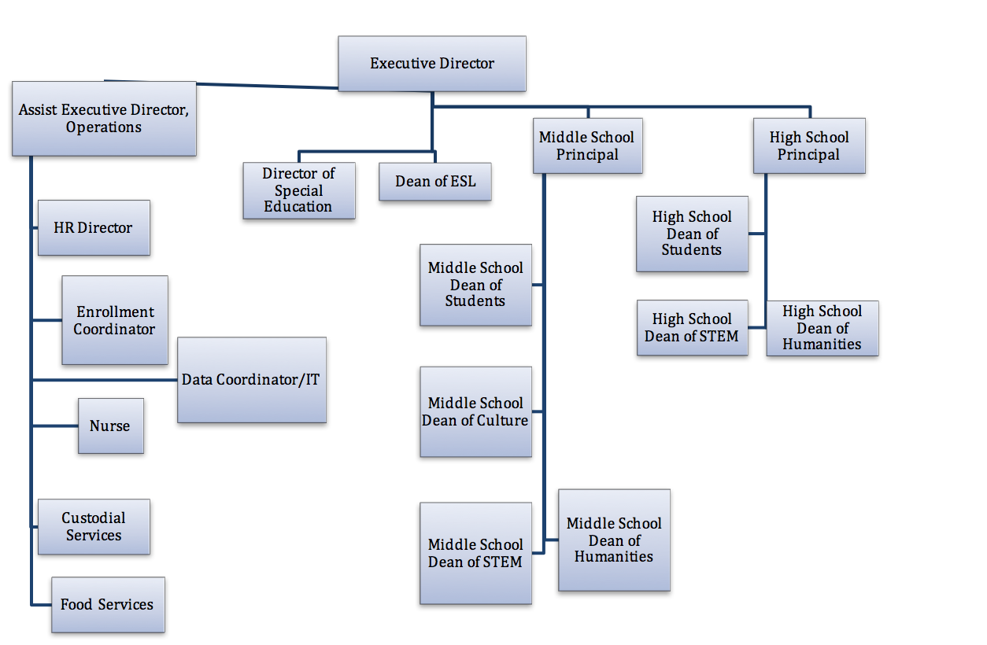

Updated Organizational Chart for 2019-2020 School Year
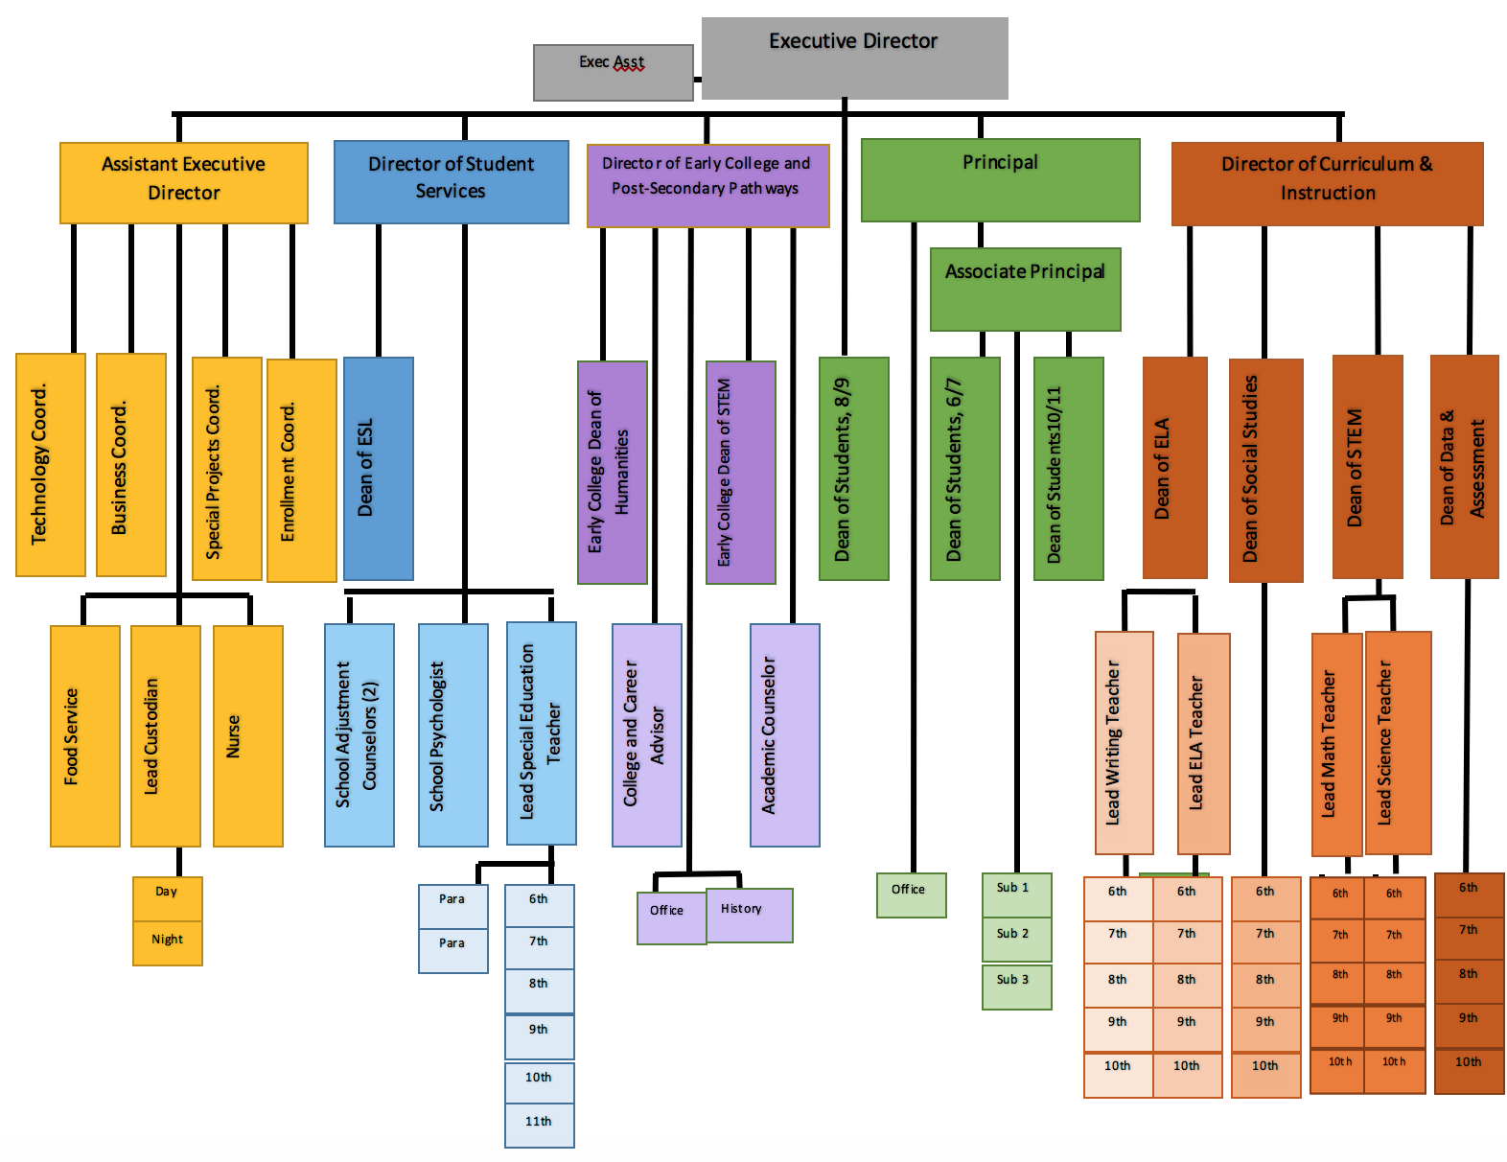

Network Structure or Multiple Campus Organizational Structure
Next year, the network organizational structure remains the same. The 2019-20 school year does require a satellite campus closer in proximity to MCC. This is not an additional school, but merely an additional space students and staff of NHCSB utilize.

Teacher Evaluation
There have been no changes to the teacher evaluation system for the 2018-2019 school year. NHCSB will continue to use the state evaluation rubric to evaluate our teachers’ holistic performance and to guide our formal observations for the 2019-20 school year. Given that NHCSB attracts new teachers, many of whom are in the process of completing their steps toward obtaining their highly qualified teacher certification, we tailor our evaluation system to be a comprehensive view of the teacher’s performance, professionalism, and progress toward achieving their personal and student growth goals.

Budget and Finance

A. Unaudited FY19 statement of revenues, expenses, and changes in net assets (income statement)
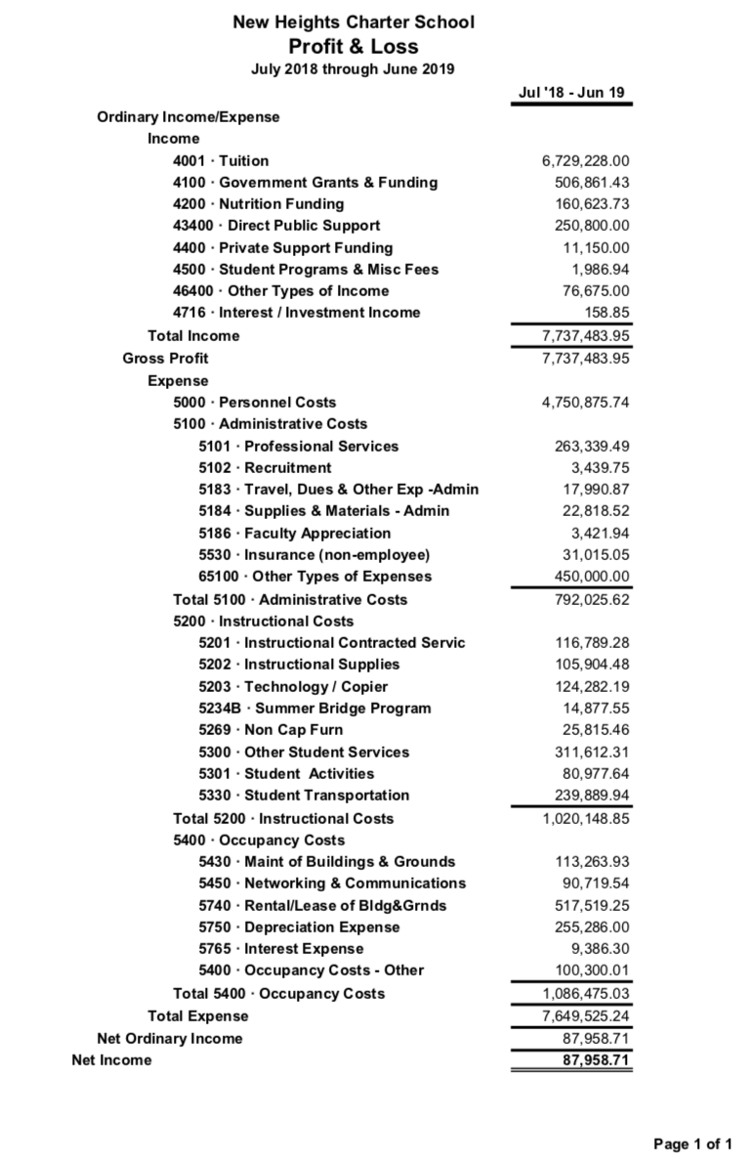

B. Statement of net assets for FY19 (balance sheet)
The balance sheet should set forth the charter school’s assets, liabilities, and fund balances or equities in the same format and using the same line items that will be included in the audited statement.

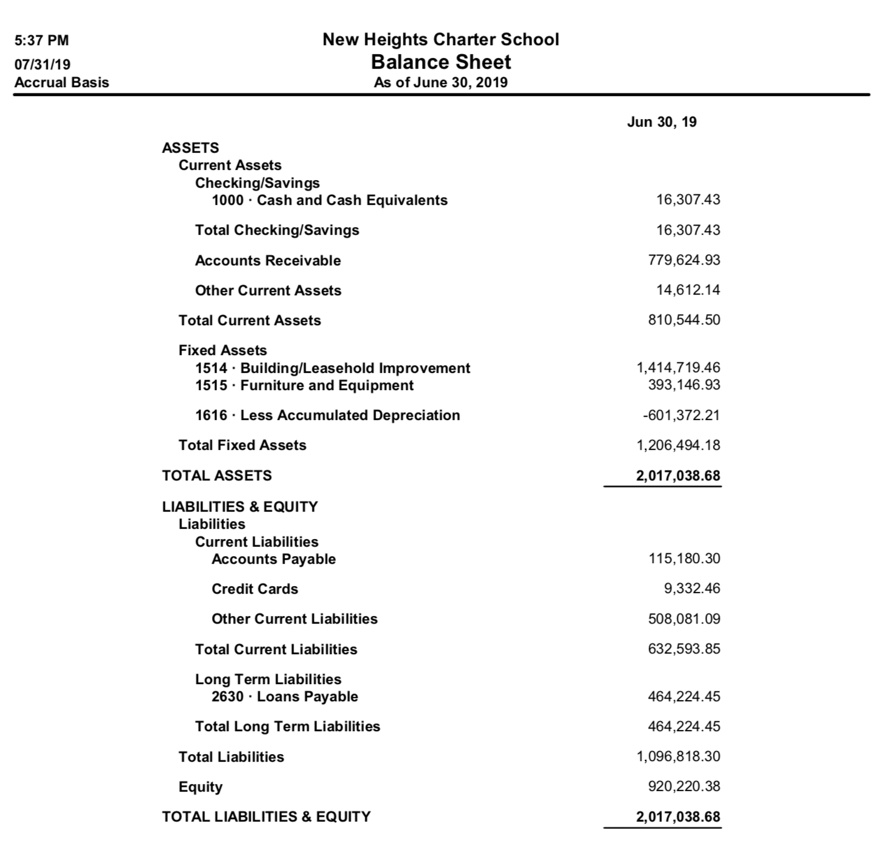

C. Approved School Budget for FY20
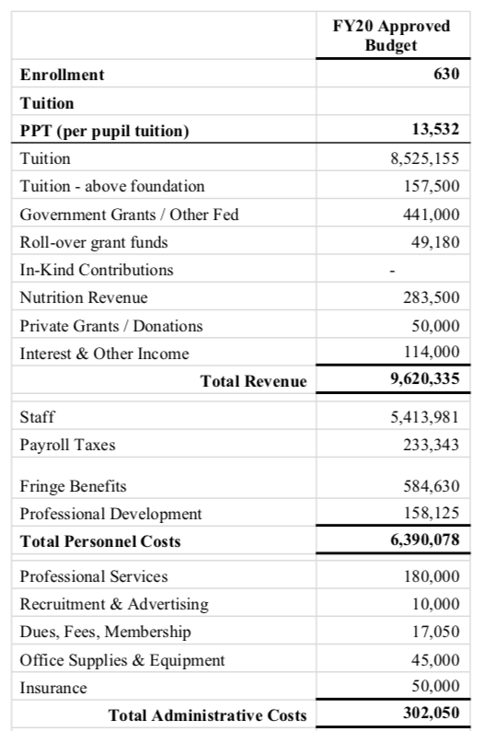
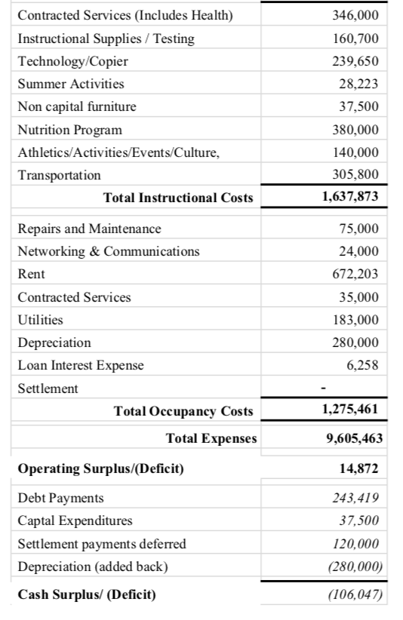

D. Capital Plan for FY20
NHCSB does not currently have a Capital Plan for FY20. However, it is our goal to purchase the 1690 Main St. Building with which our current 6-10th grade resides by the beginning of 2020-21 academic school year. Upon purchase, construction would ensue to add 6 more classrooms, a cafeteria, and a gym. The Executive Director has begun conversations with the Board surrounding this and will spend the 2019-20 crafting said Capital Plan for Board approval.

Additional Information

Accountability Plan Performance for 2018-2019
Please use Appendix A to report on the school’s Accountability Plan performance in 2018-2019. Please report on the school’s approved Accountability Plan.

Recruitment and Retention Plan
Please use Appendix B to report on the implementation of the school’s 2018-2019 Recruitment and Retention Plan and to create a plan for the 2019-2020 school year. Schools should tailor their new 2019-2020 Recruitment and Retention strategies to their individual school community and describe meaningful strategies and/or long-term plans. The goal of these plans is to outline strategies to effectively attract, enroll, and retain a demographically comparable population to similar grades in schools from which the school enrolls students. Plans will require revisions if they do not meet the guidelines or reflect changes in demographic data within the school determined time frame.

School and Student Data
Complete the data tables in Appendix C. In addition to completing the tables, please provide a brief narrative describing teacher attrition trends during the 2018-2019 school year.

This 2018-19 school year proved to be a challenging year regarding the retention of teachers. Knowing the direct impact and correlation between effective teachers and student outcomes, the Executive Director enlisted the Asst. Executive Director along with the Business Manager to conduct exit interviews and informal check ins with staff to unearth the causes of staff turnover. These conversations illuminated three primary causes or concerns that influenced a staff member’s decision to seek employment elsewhere:
- Job security. Unease regarding the “at will” clause in employment offers and letters.
- Longer school day. Charter dictates a 3:30pm dismissal; however, the challenges regarding busing required NHCSB to extend to 4:00pm in Year 2.
- Desire for a transparent and predictable payscale.
The ED brought these concerns to the Board along with solutions to rectify them. The Board approved the removal of the “at will” clause to employment letters for SY19-20 on, ensuring due process. They also approved providing staff with commitment letters earlier in the school year for the following year to ensure the retention of our strongest teachers. Additionally, a transparent pay scale for teachers was created and approved as of December, 2018, allowing us to compensate our teachers either 97% or 100% of the Brockton Public Schools teacher salary scale. After discussion and negotiation with bus companies and schedules, the SY19-20 school day will end per our original charter at 3:27pm. The ED introduced these changes to the staff in early February, which stemmed the tide of teacher attrition.

Additional Required Information
A number of charter school changes may not require an amendment request but do require that the school inform the Department in a timely fashion (603 CMR 1.08(11)). Complete the data tables in Appendix D to provide the Department with information regarding changes in leadership and/or facilities.

Anticipated Board Meeting Schedule for 2019-2020
The New Heights Board is scheduled to meet, pending unexpected events, the final Tuesday of every month during the academic school year from September-June, with a Board retreat tentatively scheduled for August 11th, 2019 prior to the start of the 2019-20 school year.
- August 11, ½ Board Retreat
- September 24
- October 29
- November 26
- December 17 ** Due to the holidays
- January 28
- February 25
- March 31
- April 28
- May 26
- June 30
This schedule will be updated on the Board page on the website as well is in our school calendar.

Conditions
New Heights was not placed on conditions—either with or without a designation of probationary status—by the Commissioner or the Board of Elementary and Secondary Education. NHCSB submits its balance sheet, profit & loss, and statement of cash flow to DESE on a monthly basis per an agreement, not condition.

Complaints
New Heights did not receive any official complaints (written) received by the Board of Trustees during 2018-2019 pursuant to the state’s charter school regulations, 603 CMR 1.09. However, the Board requested an update to the school’s website, https://www.newheightscharterschool.com/governance/, to ensure all stakeholders have direct access to the complaint procedure per the Board.

Attachments (optional)
Any attachments should be explicitly referred to in the text of the report and must be directly relevant to that part of the text. Attachments do not count toward the 25 page maximum but should not exceed 5 pages in total. This attachment is in addition to any accountability plan evidence attachments.

Attachment A
Dissemination Section:
Connecting Activities Meeting Calendar & Program Description

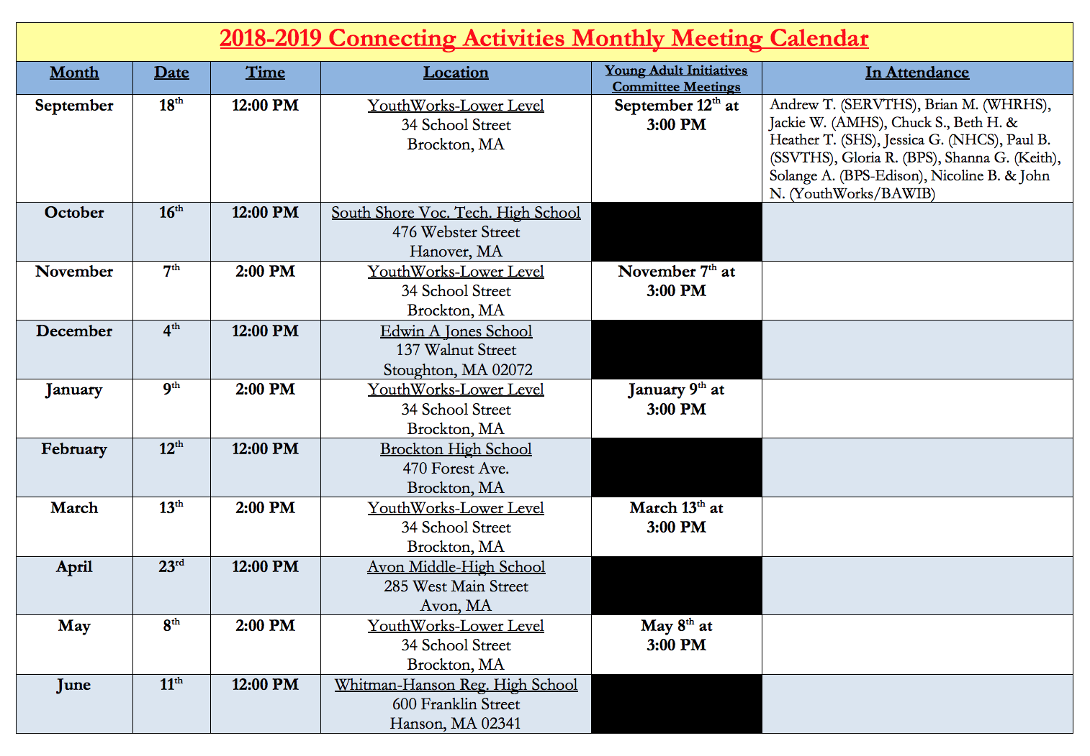

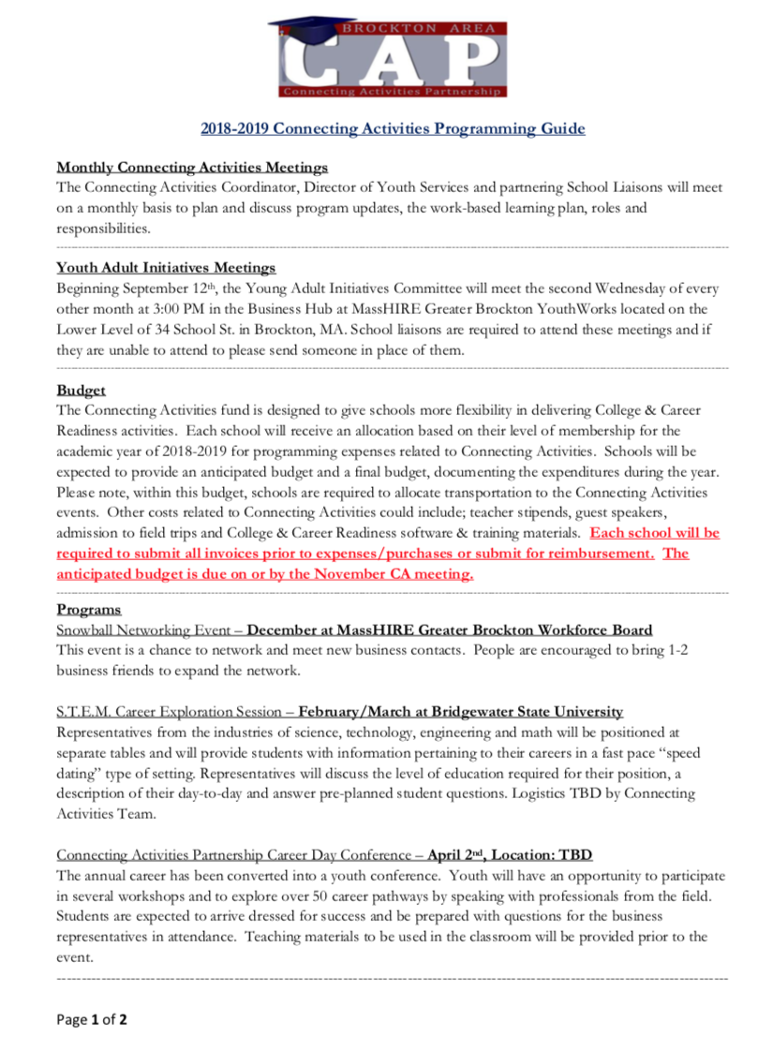
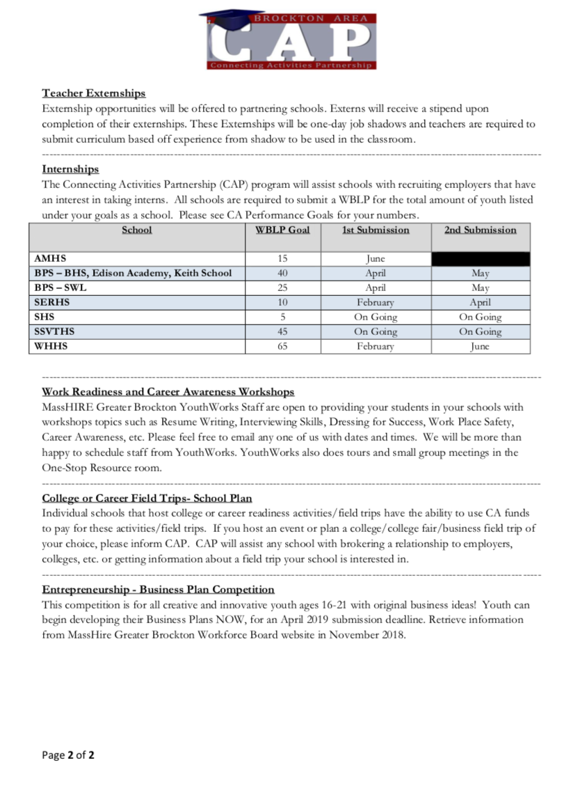

Appendix A

Accountability Plan Evidence 2018-2019

Faithfulness to Charter | 2018-2019 Performance | Evidence (include detailed evidence with supporting data or examples)
Objective: Every student will be prepared for college (Fast Track Early College Design)
Measure: Twice annually, as measured by the student survey, 85% of all students will agree with the following statements:  ● I am learning to write effectively  ● I am learning to think critically  ● I am learning to work independently  ● I ask questions or answer questions in class everyday  ● I receive feedback from my teachers everyday  ● I agree that NHCSB has helped me develop the skills/knowledge that I need for college-level classes | Met | Evidence from internal student surveys:  - I have to work hard to receive good grades- 90% of students agreed or strongly agreed.  - Do you feel the work is too easy?- 8% of students responded ‘yes’  - My teachers are available for extra help if I need it.- 78% of students agreed or strongly agreed  - I am learning to write effectively- 78% of students agreed or strongly agreed  - I am learning to think critically- 73% of students agreed or strongly agreed  - I am learning to work independently- 85% of students agreed or strongly agreed  - I ask questions or answer questions in class everyday- 21% of students disagreed  - My teachers encourage students to share their ideas about what we are learning in class- 80% of students agreed or strongly agreed  - New Heights has helped me develop the skills/knowledge that I need for college-level classes- 73% of students agreed or strongly agreed  DESE, in partnership with the Massachusetts Department of Higher Education (DHE), identified two distinct pathway options—an Early College Pathway and an Innovation Pathway— to promote college and career readiness for high school students. The Early College Pathway (ECP) is focused on college readiness and emphasizes attainment of at least 12 postsecondary credits, NHCSB is a recipient of this grant and the Early College designation as of this year. DESE hired ICF to conduct an independent evaluation of this statewide program. One element of the evaluation is a student survey administered to pathway students from all participating schools. Many of the questions relate to and elaborate on the statements outlined in our own internal survey. The survey was only given to HS students as they are more directly immersed in the early college programming (developmental courses and actual MCC credit-bearing courses.)  Have you participated in this activity during the 2018-19 school year?  - Participated in college or career advising (e.g., a college and career readiness class, an advising program, etc.) 83%  - Listened to a guest speaker present on career information 78%  - Learned about options after high school graduation, such as earning a certificate, Associate’s, Bachelor’s degree, or other credential- 83%  - Visited a college campus- 97.9%  - Learned about the costs of college and options for paying for college- 88.5%  - Learned what it takes to succeed in college- 85.6%  My pathway program (early college) has…  - …encouraged me to enroll in a two‐year or four‐year college, technical school, or certificate program 82.6% agree or strongly agree  - …motivated me to want to learn the skills needed for a specific job/career- 77.1% agree or strongly agree  - …provided me with enough advising opportunities to help me make choices after high school that are right for me- 75.1% agree or strongly agree  In addition to students’ survey responses, assessment data and the number of credits earned provides support and a more comprehensive picture of students’ preparation for college courses.  Writing Accuplacer Results/Data:  - 86% of 8th graders who took the Spring Accuplacer received the highest score on the writing section and placed into College Composition 101  - 45% of 9th graders who took the Spring Accuplacer received the highest score on the writing section and placed into College Composition 101  Reading Accuplacer Results/Data:  - 100% of 8th graders who took the Spring Accuplacer placed within the top range for reading, exempting them from having to take a developmental college reading course and placing into a college credit-bearing course.  - 49% of 9th graders who took the Spring Accuplacer placed within the top range for reading, exempting them from having to take a developmental college reading course and placing into a college credit-bearing course.
Measure: By graduation, 100% of NHCSB students will complete Massasoit prerequisite developmental courses in math and English by the 11thgrade.  ● In year 2 (2017-2018), 30% of 9thgrade students will pass (C or higher) the Massasoit Community College development course sequence in math and English.  ● In Year 3 (2018-2019), an additional 55% of the 10thgrade class will pass (C or higher) the Massasoit Community College development course sequence in math and English for a total of 85% of students completing the requisite courses in math and English by the 10thgrade.  ● In Year 4 (2019-2020), the remaining 15% of students will pass (C or higher) the Massasoit Community College development course sequence in math and English for a total of 100% of students completing the prerequisite courses in math and English by the 11thgrade.  ● In Year 4 and 5, 100% of NHCSB students will complete Massasoit prerequisite developmental courses in math and English by the 11thgrade. | Met | The inclusion of the ACCUPLACER as an additional measure determine the academic readiness of college coursework allowed for some students to enroll in college credit-bearing courses whilst continuing to complete the 001-003 in ALEKS. Despite being in Year 3, and year 2 with 9th and 10th grade students, a percentage of our students have surpassed the math sequence outlined in our charter proposal, nearly 3 years ahead of what we’d anticipated. During the spring semester, we had students enrolled in College Algebra, Pre-Calculus, and Calculus.  Additionally, the semester-based schedule and courses allowed for 9th grade students this year another at-bat for passing the ELA developmental courses, 095. Students who did not earn the required C- or higher in the fall we re enrolled in 095 for the spring. This gave students an opportunity to improve and hone their reading, writing, and speaking skills, allowing them to forego 099 in their 10th grade year for a college course.  In year 2 (2017-18), 75% of 9th grade students passed ENGL 095 with 66 total students enrolling in Comp 101 in the fall of their 10th grade year. Of the 66, 61 passed Comp 101 with a C- or higher.
Objective: NHCSB will create a unique culture to support all students (We Go to College Culture)
Measure: Twice annually, as measured by the student survey, 85% of all students will agree with the following statements:  ● I feel good about being in this school  ● I care about this school  ● I feel safe in this school  ● I feel supported by the staff at this school  ● I am comfortable being myself in this school  ● This school’s rules are fair  ● I am an important part of my school community | Making Progress | Students were given the same survey in the fall and in the spring of 2018-19 academic school year. Below reflects the average between the two administration dates, and include both the middle and high school students. The # of responses varied from fall (480) to spring (320) due to a number of factors that the leadership team plans to address and correct for the 2019-20 school year. For example, it is important to be mindful regarding the time of year the surveys are given to students. 6th graders and transfer students who are new to the school need ample time to be immersed in the school to provide an accurate representation of their feelings. Additionally, there will be adequate training for teachers and advisors prior to students taking the surveys so that all students receive the same context/preface and understand how to take the survey and what the results are used for. The percentages for the stipulated statements are below:  ● I feel good about being in this school- 77%  ● I care about this school- 65%  ● I feel safe in this school (this was evidenced through statements regarding frequency that students experienced bullying, threats, physical/emotional safety, etc)- 85%  ● I feel supported by the staff at this school- 73%  ● I am comfortable being myself in this school- 77%  ● This school’s rules are fair-70%  ● I am an important part of my school community- 72%  Overall average of 75% of agreement on the statements.
Measure: NHCSB will run a Summer Bridge program for returning students to create a culture that supports students’ preparation for college and upholds our unique “We Go to College Culture”.  ● In Year 1 (summer of 2017), a minimum of 60% of returning students will attend Summer Bridge  ● In Year 2 (summer of 2018), a minimum of 70% of returning students will attend the Summer Bridge  - In Year 3 (summer of 2019) and beyond, a minimum of 80% of returning students will attend the Summer Bridge. | Making Progress | Meeting the first two years measures and desired participation percentages, this year the number of students attending Summer Bridge was reduced to a maximum of 50 rising 9th graders for several reasons. Without an acting DCI, there was great difficulty creating curriculum for the summer bridge programming. Additionally, the leadership team spent most College Working Group meetings discussing focusing on the upcoming college course sequence for the 2019-20 school year and other logistical elements learned throughout the year. Lastly, the unexpected need of a new satellite space to house our college going students closer to MCC posed great additional financial difficulties. As a temporary measure, Summer Bridge was available to 50 rising 9th grade students for the 2018-19 school year, but regular plans will resume as planned for next year. Now that have the sequence fleshed out, focus on the Bridge program can resume. The partnership of the DCI, Director of Early College and Post-Secondary Pathways, College Advisor, and the entire Instructional Leadership Team as well as Connecting Activities and YouthWorks, this measure will easily be met, as it was in the past two years, at the end of next year.

Faithfulness to Charter | 2018-2019 Performance  (Met/Making Progress/Not Met) | Evidence (include detailed evidence with supporting data or examples)
Objective: NHCSB will provide comprehensive professional development for all staff and support the development of community partnerships
Measure: Every year 100% of NHCSB instructional staff will participate in over 150 hours of professional development that are aligned to our mission, culture, and innovative early college design. | Met | As evidenced in the PDP table provided earlier, teachers received 114 hours (see attachment) worth of professional development workshops that took place during retreats and Friday afternoons. In the mid-year survey, teachers expressed a need for time to schedule doctor’s appointments and other personal matters that are tough to schedule given our extended school day. In an effort to provide this time, the leadership team designated one Friday a month as an early release. While this lessened the desired hours, it elevated staff morale and lessened staff absences during the week. Additionally, the 114 does not include the weekly coaching meetings teachers have with their dean or lead teacher, which equates to a minimum of one hour weekly, or a total of 36 hours given the number of instructional weeks in the academic school year. Formal PD in addition to a minimum of 36 hours of coaching equates at least 150 hours, thus meeting this measure.
Measure: Twice annually, as measured by the staff PD survey, 90% of all staff will agree with the following statements:  ● I feel good about being in this school  ● I care about this school  ● I feel supported by the administration at this school  ● I feel heard by the administration  ● NCHSB PD is helping me improve my teaching practice  ● NHCSB PD is a good use of my time | Making Progress | Below are the statements and averaged results (between middle and high school) from the staff survey given to staff during the 2018-2019 school year. The percentage next to the statement reflects either agree or strongly agree. Neutral or undecided responses were not counted as an agree. The percentages below are reflective of the fall surveys as the spring surveys for staff did not occur.  - I feel good about being in this school- 82%  ● I care about this school- 100%  ● I feel supported by the administration at this school- 70%  ● I feel heard by the administration- 65%  ● NCHSB PD is helping me improve my teaching practice- 67%  ● NHCSB PD is a good use of my time- 60%  As a direct result of the staff survey and the 3 statements needing the most attention, the leadership team addressed each through the implementation of the following:  - First 15-30 minutes on Friday afternoons were allocated as Town Hall meetings facilitated by the Executive Director. The intent behind these meetings were to improve the dialogue and communication of the school and for teachers and staff to share concerns or ask questions to administration.  - Professional Development for the second semester was differentiated in order to provide teachers with a variety of different sessions more closely aligned to their current practice and needs in the classroom.
Measure: New Heights Charter School invest in developing community partnerships to support the learning experience for students, including new opportunities for learning and family engagement. During our first five years, NHCSB will develop 5 community partnerships within our charter region. | Making Progress | Given that this measure states that within 5 years, NHCSB has two more years to ensure and secure at least 5 community partnerships. At this juncture, the school has 4 strong partners with:  - YMCA  - Connecting Activities/Youth Works  - Massasoit Community College  - Health Imperatives  This year, NHCSB worked with Connecting Activities, MassHire, and YouthWorks on numerous occasions now that our students were of age to participate. Students attended workshops off campus with many other schools regarding networking, financial aid, resume building, etc. This year, our school nurse forged a relationship/partnership with Health Imperatives. Teachers and volunteers from the organization provided age-appropriate health workshops for both our middle and high school students on our campus. Students attended sessions on healthy relationships, managing emotions, conflict resolution, dating abuse, and consent.  Additionally, NHCSB has connections, not formal partnerships, with several community churches in the Brockton area. NHCSB plans to spend the next two years continuing to strengthen our partnership with the city of Brockton and the public schools within it. This past year we’ve utilized city fields for our athletic programs and rented auditoriums within Brockton schools for larger award ceremonies and school culture events, such as the 8th grade Step Up Graduation. It is our hope to strengthen and deepen these relationships.

Dissemination | 2018-2019 Performance  (Met/Partially Met/Not Met) | Evidence (include detailed evidence with supporting data or examples)
Objective: In our first charter term, NHCSB will establish best practices, identify a partner, and develop a collaborative partnership with a district. NHCSB will also share best practices through panels and conferences.
Measure: During the first term of our charter, NHCSB will work to identify best practices, establish a school partner, and develop a collaboration with the school partner.  ● By the end of Year 2 (2017-2018), NHCSB will identify and document best practices.  ● By the end of year 3 (2018-2019), NHCSB will identify a public school partner with whom to share best practices.  ● By the end of year 4 (2019-2020) and in year five (2020-2021), NHCSB will collaborate with our partner school to share best practices. | Met | NHCSB submitted an Early College Designation Application which included documentation of best practices at the school. NHCSB was awarded the Early College grant and designation, which affords leadership team members the opportunity to meet and discuss early college programming during DESE sponsored workshops. Additionally, NHCSB recently became a member of MCNC (Middle College National Consortium) and has attended two conferences during the 2018-19 school year (see section on Dissemination.) Whilst at the conferences, the team met with key stakeholders from Rhode Island and Alaska to share best practices and brainstorm policy issues/concerns. The school also partnered with Attleboro and Franklin school districts in the implementation of Illustrative Mathematics, hosting PD on site during August. This upcoming 2019-20 school year, NHCSB plans to partner with Southeastern Regional Vocational Technical Institute to provide our students with more options in athletics (football specifically.) The school hopes to continue to cultivate the partnership with Brockton public schools during years 4 & 5 of the charter.

Reach Objectives and Measures (if applicable) | 2018-2019 Performance  (Met/Partially Met/Not Met) | Evidence (include detailed evidence with supporting data or examples)
Objective: NHCSB will prepare all students for success in college
Measure: Each year of our charter term, an increasing number of NHCSB students will earn college credit during high school. By the end of our first charter term, at least 50% of NHCSB students will earn a C or higher in 2 or more college courses. | Met | Evidence:  - 98% of 10th graders had the opportunity to enroll in a college, credit-bearing course in the 2018-19 school year.  - 93% of the 10th graders have earned at least 3 college credits at the end of the 2018-19 school year.  - 69% of 10th graders have earned at least 6 college credits (two college courses)  - 29% of 10th graders have earned 9 or more college credits (three college courses)  - 20% of 10th graders have earned 13 college credits (four college courses)  - In total, NHCSB students have earned a collective total of 596 college credits at the end of the 2018-19 school year.  - 12 9th grade students have earned 3 or more college credits at the end of the 2018-19 school year (a year ahead of schedule.) Of those 12, 4 students have earned 7 credits (2 college courses,) and 4 students have earned 11 credits (3 college courses.)  - 5 8th grade students completed the Math Developmental course sequence during the fall. Students took the ACCUPLACER math exam along with 9th and 10th grade students, and they placed into College Algebra for the spring. 100% of those students passed the college course.

Appendix Aa
2019-20 Academic Calendar
ent and Retention Plan Templ
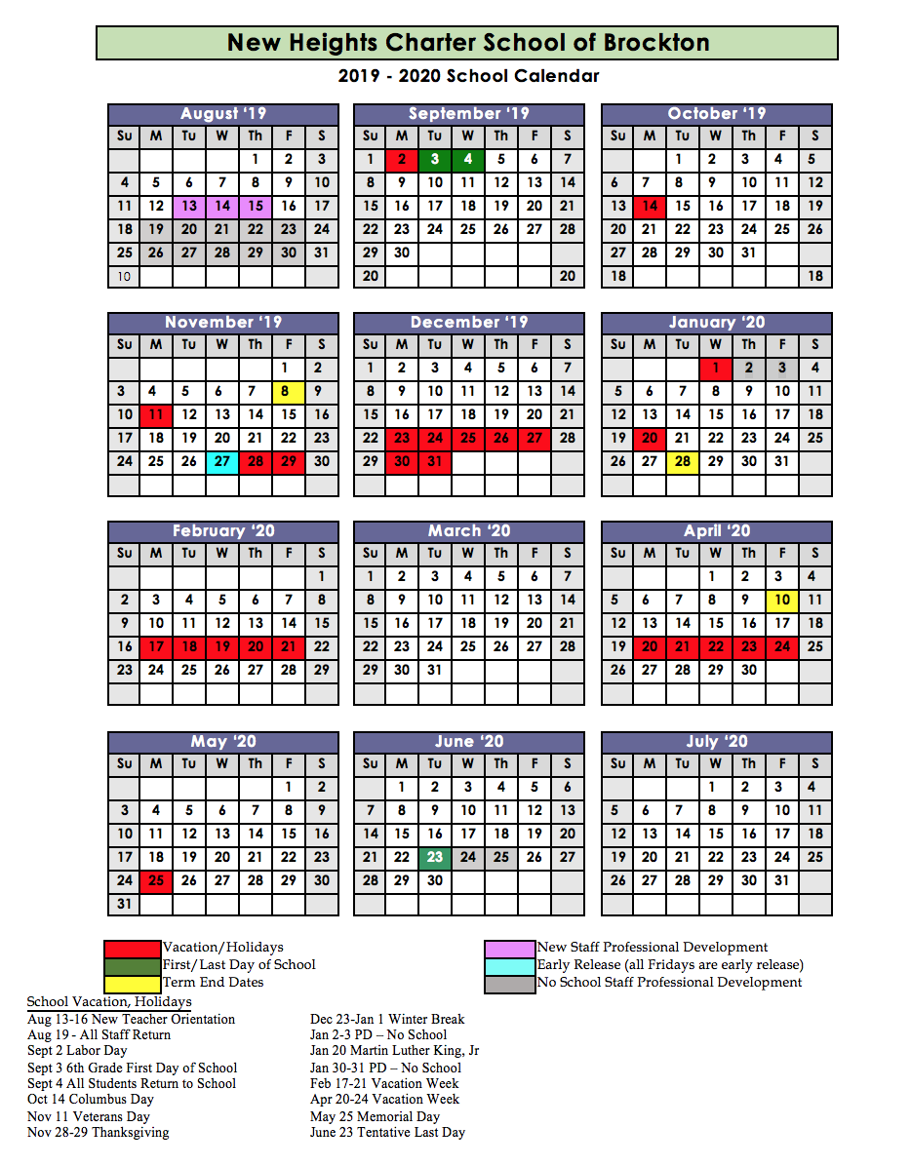

Appendix B
Charter School Recruitment and Retention Plan Template

Recruitment Plan
2019-2020

School Name: New Heights Charter School of Brockton

Narrative:
During the 2018-19 school year, New Heights Charter School built upon the successes of our recruitment and retention strategies from previous years, particularly for Special Education students and English learners (ELs) as well as economically disadvantaged children, including the following:
- Focus on Promotion: NHCSB held three all open houses/informational evenings where members of the student services team, including counselors, Special Education, and ELL staff were present to answer families questions about our model.
  - New for 2019-20: One of the Open House events will be held in the winter prior to the March lottery to provide support for families who may wish to submit an application to learn more about our school.
  - New for 2019-20: New Heights will work with a marketing firm or expert to fine-tune the marketing process currently in place including the mass mailer and newspaper ads in addition to copy placed on the website to be sure our reach is broad and all encompassing.
  - Welcome to New Heights Day! NHCSB ran two Acceptance Day Open House for all new 6th grade students at the start of summer and a second Acceptance Day for all new students entering vacated seats. Special Education, counseling, and EL staff were on board to meet and support prospective students
  - NHCSB continued the practice of printing all promotional materials in Haitian Creole, Portuguese, English and Spanish. Additionally, our school website can be translated into any foreign language, which means our application can be translated into any language. Promotional materials were sent to every household with an age-eligible child within our region. In addition, NHCSB ran ads in the local papers before our application due date and again before the lottery.
  - Bilingual staff was available at all of our open houses in order to support Limited English Proficient (LEP) families.
- Cultural Presence in School: We continued to build on our myriad cultures that compose our student and staff body with a particular focus on building cultural competencies in our teachers through targeted professional development.
  - New to 2019-20: Staff members will undergo a number of professional development hours in cultural awareness and competencies to be used in the classroom with a focus on historical relevance and inclusion.
  - New to 2019-20: Academic coaches will work with staff throughout the year to embed cultural competencies throughout the New Heights community, for example in our open houses and acceptance days. Understanding and respecting where our students come from is essential to supporting their development when they arrive at New Heights.
- Celebratory Community Events: NHCSB held our third Multicultural Night Celebration for New Heights Families that was a huge success. Nearly 1000 members of the New Heights’ family attended this event.
  - New to 2019-20: New Heights will extend invitations to youth organizations throughout our region to attend cultural events on our campus.

New Heights’ met great success in implementing the recruitment strategies from the 2018-19 recruitment plan. Our sole remaining challenge, which the school continues to address, is how best to reach ALL families within our district. Starting in the 2017-18 school year and continuing into the 2018-19 school year, we began asking families to share with staff how they learned about New Heights and what attracted them to our school. We learned that word of mouth is a strong mode of communication, but as a strategy limits the school’s ability to reach all communities. Thus, the leadership team is working on instituting changes to the 2019-20 organizational chart, Professional Development calendar, and goal setting by department (which includes a focus on marketing and recruitment).

Subgroup Enrollment: As stated above, anecdotal evidence indicates that enrollment figures are primarily driven by word-of-mouth recruitment. We find that many of our students are related through family or through cultural organizations. We believe this phenomena, whereby families learn of our existence through currently enrolled students, may impact our subgroup enrollment as well. In addition, we have a great number of siblings who are enrolled at New Heights. Finally, as a third-year initiative, New Heights has increased resources in our Student Services department, hiring a new staff member to take over the department and reorganize student classification, which lead to sizable decreases in our EL and Special Education enrollment numbers, to the benefit of our students.

October SIMS: Following the trends from 2017-18 and 2018-19 we believe that our 19-20 school year will reflect growth in all areas, closing gaps in recruitment for all key areas. Our growth this year in closing the gap, particularly with economically disadvantaged students, indicates that our initiatives are working - a personalization of the recruitment process through small group tours and meet-and-greets with key members of the leadership team as well as enrollment fairs that assist families through all aspects of the enrollment process, ensuring ALL stakeholders’ needs are met in real time. We believe this trend will continue, more students will express interest in attending New Heights from all subgroups.

Describe the school’s general recruitment activities, i.e. those intended to reach all students.
General Recruitment Activities for 2019-2020:
- Focus on Promotion: NHCSB held three all open houses/informational evenings where members of the student services team, including counselors, Special Education, and ELL staff were present to answer family’s questions about our model.
- New for 2019-20: One of the Open House events will be held in the winter prior to the March lottery to provide support for families who may wish to submit an application to learn more about our school.
  - New for 2019-20: New Heights will work with a marketing firm or expert to fine-tune the marketing process currently in place including the mass mailer and newspaper ads in addition to copy placed on the website to be sure our reach is broad and all encompassing.
  - Welcome to New Heights Day! NHCSB ran two Acceptance Day Open House for all new 6th grade students at the start of summer and a second Acceptance Day for all new students entering vacated seats. Special Education, counseling, and EL staff were on board to meet and support prospective students
  - NHCSB continued the practice of printing all promotional materials in Haitian Creole, Portuguese (the official language of Cape Verde), English and Spanish. Additionally, our school website can be translated into any foreign language, which means our application can be translated into any language. Promotional materials were sent to every household with an age-eligible child within our region. In addition, NHCSB ran ads in the local papers before our application due date and again before the lottery.
  - Bilingual staff was available at all of our open houses in order to support Limited English Proficient (LEP) families.

2. Cultural Presence in School: We continued to build on the myriad cultures that compose our student and staff body with a particular focus on building cultural competencies in our teachers through targeted professional development.
- New to 2019-20: Staff members will undergo a number of professional development hours in cultural awareness and competencies to be used in the classroom with a focus on historical relevance and inclusion.
- New to 2019-20: Academic coaches will work with staff throughout the year to embed cultural competencies throughout the New Heights community, for example in our open houses and acceptance days. Understanding and respecting where our students come from is essential to supporting their development when they arrive at New Heights.

3. Celebratory Community Events: NHCSB held our third Multicultural Night Celebration for New Heights Families that was a huge success. Nearly 1000 members of the New Heights’ family attended this event.
a. New to 2019-20: New Heights will extend invitations to youth organizations throughout our region to attend cultural events on our campus.

Recruitment Plan:
2019-2020 Strategies
Special education students/students with disabilities
(a) CHART data  School percentage:10.2%  GNT percentage: 8.7%  CI percentage: 12.1%  The school is above/GNT percentages and below CI percentages | (b) Continued 2018-2019 Strategies  X Met GNT: no enhanced/additional strategies needed  Strategy 1: Students at New Heights who have an IEP or a 504 will be assigned to a Special Education Teacher who will also act as their case manager. Each student’s case manager will consistently review and revise student plans and communicate with parents and families regarding their students’ progress and growth throughout the school year. Additionally, each case manager will act as the students advocate for their education, fight for each students’ educational rights and ensure the implementation of their IEP or 504 plans.  Strategy 2: During each New Heights open house, information session or recruitment event, New Heights will have Special Education staff in attendance to answer questions, provide information and encourage families to consider New Heights for all students.  Strategy 3: At the start of the school year, the New Heights Special Education Department will invite families to join the New Heights SEPAC organization. Additionally, at the start of the school year, the Director of Student Services will host an information session for parents within the Special Education Department to explain their parental rights, review and understand qualifying disabilities and review systems and procedures within the department (i.e. annual review meetings, re-evaluation meetings, accommodations, etc.). Lastly, a Special Education staff member will be in attendance at parent meetings throughout the school year to answer any questions that parents and families may have.  Strategy 4: All students with an IEP or a 504 had a case manager for the entire school year who reviewed and revised their plan as needed, communicated with parents and families regarding their student and was an advocate for the students on their caseload.
(c) 2019-2020 Additional Strategy(ies), if needed
Given that many high school students will be taking college courses, students with an IEP or 504 will be informed of the resources available to them on our college partner’s campus as well as any college he/she may attend. When our students are in a college course or on a college campus, they are college students and therefore are responsible for informing professors of their accommodations. This information will be presented to parents and families at open houses and during meetings with their case manager and parents.
Limited English-proficient students/English learners

(a) CHART data  School percentage: 10.7%  GNT percentage: 5.6%  CI percentage: 11.2%  The school is above/GNT percentages and below CI percentages | (b) Continued 2018-2019 Strategies  X Met GNT no enhanced/additional strategies needed  Strategy 1: Our Director of EL Services will continue to work with our students and the community, holding information sessions and ensuring our materials are translatable. In addition, many of NCHSB’s staff is bi-or multilingual, a skill that serves our students, their families and the community.  Strategy 2: Next year, we will have one open house in the fall and one in the spring. Both will be held at New Heights. We will advertise for our information sessions in English, Portuguese, Haitian Creole, and Spanish.
 | (c) 2019-2020 Additional Strategy(ies), if needed
Students eligible for free or reduced lunch (Low Income/Economically Disadvantaged)
(a) CHART data  School percentage: 40%  CI percentage: 40.9%  The school is below CI percentages | (b) Continued 2018-2019 Strategies  Did not meet CI: enhanced/additional strategies needed  Strategy 1: Student Services: New Heights will continue to advertise our extensive student services support via Parent Meetings or Prospective Student Site Visits. These services include ou  Strategy 2: Social Workers: Review student records during the summer to identify any “red flags” and set-up meetings with students (and families, if necessary) to ensure NHCSB is bridging the gap in services for students.  Strategy 3: Health Care: Provide annual dental and vision screenings for students onsite.  Strategy 4: Laundry Services: Provide onsite laundry services for students who do not have access to washing/drying machines.
(c) 2019-2020 Additional Strategy(ies), if needed
Did not meet CI: During the 2018-19 school year, New Heights school percentage of economically disadvantaged students was 39.3. However, during the 2019-18 school year, we show an improvement of 1%. During the 2019-20 school year, the school will use the following strategies to recruit economically disadvantaged students:
Strategy 1: Student Services: New Heights will continue to advertise our extensive student services support via Parent Meetings or Prospective Student Site Visits. These services include mental counseling, partnerships with local agencies (such as YouthWorks) and medical support groups (including visiting dental and vision specialists), laundry, and nutrition programming, such as CEP enrollment.
Strategy 2: Direct Marketing: In our first four years of student recruitment, New Heights relied heavily upon a direct marketing agency to send out mailers about our school in our four primary languages. We learned from families who attended our Open Houses that the mailer was rarely the reason they knew about our school and it was more likely word-of-mouth that influenced their decision to visit. For our 2019-20 recruitment season, New Heights will employ a marketing firm with experience working on student recruitment with charter schools in Massachusetts to help us to create materials that will target specific student populations. This organization will revamp our website and our media presence, ensuring our message is clear and reaches all corners of our district.
Strategy 3: Door-to-Door Campaign: During the pre-operational recruitment period prior to New Heights’ first year, our team went door-to-door in our three districts, focusing specifically on housing projects and low-income neighborhoods – particularly the businesses in these neighborhoods. Our staff brought the New Heights’ message to prospective students and families and, as a result, over 900 students completed applications to attend our school. During the 2019-20 recruitment season, New Heights staff will once again visit housing projects in our primary districts as well as businesses in low-income neighborhoods including hair salons, laundromats, and supermarkets.
We believe these three strategies – holding Open Houses, creating a professional marketing campaign including materials to reach out to prospective families, and a door-to-door approach – will increase our recruitment of low-income students, as well as increases our presence in the community.

Students who are sub-proficient | (d) Continued 2018-2019 Strategies  Goal: We expect to meet or exceed district enrollment levels due to our recruitment strategies.  Strategy 1: Attend meetings at schools, when invited, to encourage students who may be sub-proficient to consider the smaller learning environment at NHCS, our “Academic Boot Camp” offered in the Lower School, in addition to our Summer Bridge program, all designed to bring students to proficiency and prepare them for the next steps.  Strategy 2: We will include descriptions of our programming as it relates specifically to increasing proficiency, from the use of double-blocked English and Math to the inclusion of developmental courses at MCC.  2019-2020 Additional Strategy(ies), if needed  We do not believe new strategies are required per our early testing and identification of students. Plus, the addition of a college and career advisor and academic counselor will provide all students with access to a professional who can assist them in understanding and assessing their strengths and areas for growth, and then form a plan to ensure academic progress.
Students at risk of dropping out of school | (e) Continued 2018-2019 Strategies  Goal: We expect to meet or exceed district enrollment levels due to our recruitment strategies.  Strategy 1: Early College was originally envisioned as a dropout prevention tool. In our promotional materials, and throughout our public appearances we will remind students that attending NHCS means the opportunity to pursue courses of interest in college. We will focus on what makes us different from “traditional” public schools, emphasizing our wraparound services.  2019-2020 Additional Strategy(ies), if needed  We do not believe new strategies are required per early identification of academic or social/emotional needs however, for the 2019-20 school year New Heights is bringing a full-time School Psychologist and a second Guidance Counselor to join our Student Services team.
Students who have dropped out of school | (f) Continued 2018-2019 Strategies  Goal: We expect to meet or exceed district enrollment levels due to our recruitment strategies.  Strategy 1: Drawing from our extensive background in Alternative Education programs, we will canvass local hangouts, parks, and community centers to talk to dropouts about re-enrolling at NHCS. We will focus on our college access and completion mission.  Strategy 2: We will work with community groups’ families with the dropout population in our region to serve as referral agencies to NHCS, again leveraging relationships already in place due to our history in Alternative Education.  2019-2020 Additional Strategy(ies), if needed  No additional strategies required at this time. New Heights has not yet enrolled a student who previously dropped-out of school. In the event the does happen, our Student Services team will work with the student to ensure they are enrolled.
OPTIONAL  Other subgroups of students who should be targeted to eliminate the achievement gap | (g) Continued 2018-2019 Strategies  Goal: We expect to meet or exceed district enrollment levels due to our recruitment strategies.  Strategy 1:We have been told that students who are not interested in attending college, perhaps for whom high school graduation is sufficient, may be discouraged from applying.  Strategy 2:We will clarify that our mission is to PREPARE students for college by removing barriers implicit to developmental education requirements.  Strategy 3:We will also remind students that the college courses are free and will be taken in place of “traditional” high school classes.  Strategy 4: We will work to assuage concerns about whether college is the “right path” for students in this category, both with concerned students as well as their families.  2019-2020 Additional Strategy(ies), if needed  We do not anticipate the need for any additional strategies.

Retention Plan
2019-2020

Please provide a brief narrative report on the successes and challenges of implementing strategies from the 2018-2019 Retention Plan.
During the 2017-18 school year, NHCSB implemented a number of strategies, listed below, to support student retention. These strategies were very successful in nearly all categories in closing the gaps in enrollment and retention, although New Heights will continue to work diligently over the 2019-20 school year and beyond to ensure that no students are left behind. Key changes for the 2019-20 school year include a newly revamped Student Services team, which includes an additional school counselor and a School Psychologist in addition to a new Director of Student Services and a new Director of English Language Services, academic coaches in all departments including an ELA coach who is revamping our entire ELA curriculum to align instruction with cultural competency. The entire leadership team is meeting throughout the summer to prepare our new staff to support the needs of our students including a new discipline program, described above, as well as a new professional development plan to support our staff. We are proud that our school nearly made our retention goal of 90% (In 2018-19 New Heights had a 10.8% attrition rate, an improvement of nearly 4% over the 2018-18 school year) and we will continue to strive to meet that goal during the 2018-19 school year.

1. Behavior System: NHCSB uses a software program called Dean’s List to support our behavior system. Dean’s List records the positive and negative behaviors of students on campus. Good behavior was awarded points that could be used to “purchase” NHCSB logo items or dress down days. The school will focus on culture development during the 2018-19 school year, including a revamping of the behavior system to better suit the needs of our students. New for the 2019-20 school year: The Principal will be joined by an Associate Principal who will manage three Deans of Students. This new “student culture” team will implement an improved culture and discipline plan for the 2019-20 school year.

2. School Culture Events: NHCSB implemented an 8th grade dance and graduation ceremony that was eagerly anticipated and widely attended, a science and art fair, multicultural event, and talent show to support the wide interests of our student population. New for 2019-20: New Heights will continue to grow our school culture events, seeking suggestions from our students, including student representation on our school wellness committee, which lead to improvements in our school lunch program for the 2019-20 school year.

3. Recognition: NHCSB continued to hold grade-specific award ceremonies to recognize the hard work throughout the year of all students and welcome them to the next grade.

4. SummerBridge: NHCSB offered free optional summer programming, SummerBridge, to a reduced number of our graduating 8th and 9th grade students for the 2018-19 school year as a result of the unexpected cost of a satellite campus. We are proud to say that next year the 3-weeks of academic enrichment and experiential learning offered during SummerBridge, including one week at Massasoit, will continue to be offered to all our high school students. New for the 2019-20 School Year: New Heights is growing through the creation of a satellite campus, close to the Massasoit campus, for all students in the high school taking college courses. A new Director of College Access and Postsecondary Pathways will lead this new initiative including the SummerBridge program, which will grow and expand under her leadership.

5. Professional (student-centered) Development: NHCSB teachers consistently met in grade level teams through Response to Intervention (RTI) protocols to better support struggling students. After the first semester and analyzing the results of the staff survey, the instructional leadership team created a differentiate PD calendar to provide teachers a variety of options to reflect their variety of needs in their own professional growth. We received positive feedback regarding this change and the quality of PD provided. New in 2019-20: At the center of New Heights’ model is a focus on professional development, this will continue to grow and expand as we address the areas of need expressed by our students and staff.

6. Special Education and EL Supports: All students with an IEP or a 504 had a case manager for the entire school year who reviewed and revised their plan as needed, communicated with parents and families regarding their student and was an advocate for the students on their caseload. EL students receive notifications from the school in their home language in addition to receiving the necessary supports at the school to succeed academically and social/emotionally. New for 2019-20: New Heights will have new leadership in Student Services to continue the work done in 2018-19, including audits of the system and one-on-one meetings with students to ensure their academic and social/emotional needs are met within our school’s program. The new Academic Counselor will work with HS students, in particular, that receive services to discuss the resources available to them on a college campus and how to self-advocate.

Overall Student Retention Goal
Annual goal for student retention (percentage): | 90% of students will be retained annually

Retention Plan:
2019-2020 Strategies
Special education students/students with disabilities
(a) CHART data  School percentage: 15.4%  Third Quartile: 12.7%  The school’s attrition rate is above third quartile percentages. | (b) Continued 2018-2019 Strategies  Activity 1  New Heights has 4 licensed Special Education teachers, 1 paraprofessional and anticipates the hiring of 2 additional Special Education teachers for the upcoming school year. Special Education teachers provide students with inclusion support, 1:1 and small group academic support, small group instruction, organizational support, decoding instruction and social skills instruction. Each student’s individual plan is dependent on the services and accommodations that are outlined in the students IEP or 504 plan. Additionally, Special Education teachers are required to communicate student progress in all areas with parents and families periodically throughout the school year to help ensure the student is supported both inside and outside of school. New for 2019-20: New Heights hired several new special education teachers, a school psychologist and a new Director of Student Services to monitor the Special Education program and our students closely as well as work with teachers to enhance instructional techniques in the classroom.  Activity 2  The Director of Student Services is present at all IEP and 504 meetings. Additionally, the Director of Student Services is a resource to both families and students regarding related supports. Lastly, the Director of Student Services provides coaching to all of the Special Education staff around supports, parent communication, meeting preparation and inclusion support to ensure that students are receiving the educational supports that they deserve. This will remain the same for 2019-20.  Activity 3 (Updated for 2019-20)  The new Director of Student Services is licensed in Special Education and will provide appropriate professional development for the whole staff to ensure that all students have meaningful access to the curriculum and are receiving the support they need to succeed in the classroom. Additionally, the Director of Student Services will hold office hours for general education teachers to receive support in the area of accommodations. Lastly, the Director of Student Services will perform accommodation audits randomly throughout general education classrooms to ensure classrooms are in compliance.
(c) 2019-2020 Additional Strategy(ies), if needed
Above third quartile: additional and/or enhanced strategies needed

Building on the work done last year, which successfully closed the gap between the school’s percentage and third quartile by 1.5% percent (last year, NHCSB reported a 4.3% gap, reducing that number this year to 2.7%). Although the gap was not closed, this reduction points to the possibility that the activities listed below are working.

Activity 1
New Heights has 4 licensed Special Education teachers, 1 paraprofessional and anticipates the hiring of 2 additional Special Education teachers for the upcoming school year. Special Education teachers provide students with inclusion support, 1:1 and small group academic support, small group instruction, organizational support, decoding instruction and social skills instruction. Each student’s individual plan is dependent on the services and accommodations that are outlined in the students IEP or 504 plan. Additionally, Special Education teachers are required to communicate student progress in all areas with parents and families periodically throughout the school year to help ensure the student is supported both inside and outside of school. New for 2019-20: New Heights hired several new special education teachers, a school psychologist and a new Director of Student Services to monitor the Special Education program and our students closely as well as work with teachers to enhance instructional techniques in the classroom.

Activity 2
The Director of Student Services is present at all IEP and 504 meetings. Additionally, the Director of Student Services is a resource to both families and students regarding related supports. Lastly, the Director of Student Services provides coaching to all of the Special Education staff around supports, parent communication, meeting preparation and inclusion support to ensure that students are receiving the educational supports that they deserve. This will remain the same for 2019-20.

Activity 3 (Updated for 2019-20)
The new Director of Student Services is licensed in Special Education and will provide appropriate professional development for the whole staff to ensure that all students have meaningful access to the curriculum and are receiving the support they need to succeed in the classroom. Additionally, the Director of Student Services will hold office hours for general education teachers to receive support in the area of accommodations. Lastly, the Director of Student Services will perform accommodation audits randomly throughout general education classrooms to ensure classrooms are in compliance.
Limited English-proficient students/English learners
(a) CHART data  School percentage: 11.1%  Third Quartile: 17.1%  The school’s attrition rate is below third quartile percentages. | (b) Continued 2018-2019 Strategies  Below third quartile: no enhanced/additional strategies needed.  Although NHCSB was below the 3rdquartile, the English Language Learners Team will incorporate several new components for the 2018-19 into our success strategies listed above:  ● Retain and hire bilingual staff. Adding an additional ESL teacher to our staff  ● Offer our LEP families more resources (i.e. informational flyers about the benefits of bilingualism, classes and/or information sessions for LEP parents after school, EL Parent Council meetings, free immigration counseling, adult ESL classes)  ● Hang the Benefits of Bilingualism posters around school  ● Have a Multicultural Dress Down Day for students  ● Distribute informational flyers at local organizations (i.e. local daycares, the YMCA, the Boys and Girls Club, the Family Center, dance schools, restaurants, etc.)
(c) 2019-2020 Additional Strategy(ies), if needed
Below third quartile: additional and/or enhanced strategies not needed.

Students eligible for free or reduced lunch (low income/economically disadvantaged)

(a) CHART data  School percentage: 12.6%  Third Quartile: 12.2%  The school’s attrition rate is above third quartile percentages. | (b) Continued 2018-2019 Strategies  Above third quartile: enhanced/additional strategies needed 19.8/11 in 2018  Strategy 1: The Social Services team will dedicate more time to supporting ALL students, particularly focusing on those students who are identified as economically disadvantaged (this can occur during advisory, afterschool “group” meetings, and during parent/family monthly meetings.  Strategy 2:Increase the presence of the Family Outreach Coordinator and his/her new counterpart, the Dean of Culture around the school, at parent/family meetings, and through special outreach activities home. These two roles will provide assistance, with the counseling staff, to ensure that economically disadvantaged students receive additional support to thrive at our school.  Strategy 3: NHCSB will continue to provide laundry services, back up uniforms loans, college access support, and free meals (dinner will be provided during the 2018-19 school year during our afterschool programming) for all students.
(c) 2019-2020 Additional Strategy(ies), if needed

Above third quartile: additional and/or enhanced strategies needed.

During the 2018-19 school year, New Heights reported a nearly 8% increase over the third quartile - 19.8% of students versus 11%. We are happy to report that we have reduced our school percentage, using the strategies reported above, by 7.2%, a note-worthy decrease we believe for a three-year old school still learning our region. We will continue to grow and adapt our strategies over the coming years to close this gap permanently. Enhanced strategies are listed below.

Strategy 1: Building on last year’s strategy to dedicate more time to students, the school social workers and the school psychologist will meet in small groups including grief counseling, “girls or boys” groups, and chat sessions with students to support their needs.

Strategy 2: The school nurse, with the school wellness committee, will dedicate time to supporting students social/emotional needs including the availability of referral services, laundry and medical attention (such as vision and dental visits).

Strategy 3: Students do not like the school lunches provided - they are too healthy, the portions are smaller than they are accustomed to, and the choices are limited. The Wellness Committee met during the school year (with students and families) to make sweeping changes to the school lunch program including new seasonings and menu selections.
Students who are sub-proficient | (d) Continued 2018-2019 Strategies  Strategy 1:Small advisory groups are built into every morning and later afternoon to support student’s academic and social/emotional learning.  Strategy 2:Students’ academic schedules include double blocking in math and English, to ensure deep and rich understanding.  Strategy 3:All students complete Massasoit’s Developmental Course sequence to ensure they meet college ready academic standards (in addition to the reinforcement of academic skills learned in high school)  2019-2020 Additional Strategy(ies), if needed
Students at risk of dropping out of school | (e) Continued 2018-2019 Strategies  Strategy 1: SummerBridge for rising ninth graders included the development of proposals to have more “ownership” over our school including the development of a school store (student-driven business plan), murals painted onto our walls conceived of and executed by students, a lending library, and more picnic benches in front of the school to make our outside more attractive to passersby and give students a place to hang-out.  Strategy 2: Build a college-going and safe/supportive culture that will include cultivating personal relationships with students and their families. Through these relationships we will know our students and we will have the tools we need to be proactive rather than reactive to meet the individual needs of all students.  Strategy 3:Introduce college coursework as soon as the student is ready, not when the school is ready. At NHCSB, college courses are the proverbial “carrot” for students who may drop out of a more traditional setting. They are promoted in our model when they are deemed ready by Massasoit’s standards, whether in 11thgrade or 8th, as was the case with a number of students during the 2017-18 school year.  2019-2020 Additional Strategy(ies), if needed
Students who have dropped out of school | (f) Continued 2018-2019 Strategies  Due to our expanding school culture and “We Go to College” mindset as well as the efforts we put into developing personal relationships with our students, exposing students early to college opportunities, we expect that we will have few students choosing to dropout of NHCSB. However, we will continue to work with students at-risk of dropping out as well as supporting students who drop-out to find an institution better suited to their individual needs or future plans.  2019-2020 Additional Strategy(ies), if needed  · Utilize the college and career counselor and the academic counselor positions to meet regularly with students who teachers and deans flag as a dropout concern per their grades and attendance.
OPTIONAL  Other subgroups of students who should be targeted to eliminate the achievement gap | (g) Continued 2018-2019 Strategies  The NHCSB key design elements, recruitment and retention model, our staffing plan, and our “culture” all point to NHCSB specifically targeting all subgroups of students, working to eliminate the achievement gap and provide ALL students with access to postsecondary education opportunities.  2019-2020 Additional Strategy(ies), if needed  · The addition of a College and Career Advisor, Early College Deans, and an Academic advisor provides a myriad of supports for students to successfully complete college courses and bridge the transitional times that prove to be challenging for students.

Appendix C
School and Student Data Tables

New Heights Charter School of Brockton’s student demographic enrollment data can be found on: http://profiles.doe.mass.edu/profiles/student.aspx?orgcode=35130000&orgtypecode=5&

STUDENT DEMOGRAPHIC AND SUBGROUP INFORMATION
Race/Ethnicity | # of students | % of entire student body
African-American | 476 | 89.5
Asian | 5 | .9
Hispanic | 37 | 7
Native American | 1 | .2
White | 11 | 2.1
Native Hawaiian, Pacific Islander | 0 | 0
Multi-race, non-Hispanic | 2 | .4
Special education | 57 | 10.7
Limited English proficient | 54 | 10.2
Economically Disadvantaged | 213 | 40

ADMINISTRATIVE ROSTER FOR THE 2018-2019 SCHOOL YEAR
Name, Title | Brief Job Description | Start date | End date  (if no longer employed at the school)
Omari Walker  Executive Director | Omari oversees the entire NHCSB operation, works directly with the NHCSB Board, supports fundraising and grant attainment activities, and provides leadership to the Head of School | Founding member | n/a
Janice Manning  Assistant Executive Director | Janice managed the daily operations of NHCSB including facilities, nutrition, transportation, technology, and custodial services | Founding member | n/a
Shana Silva  Middle School Principal | Shana oversees the middle school academic program, parent support and school culture and NHCSB. | August 1, 2018 | n/a
Meredith Morrison  High School Principal | Meredith oversees the High School academic program, parent support and school culture and NHCSB. She is also the senior building administrator. | Founding member  This role: August 1, 2018 | August 1, 2019
Neal Klayman  Middle School Dean of Students | Neal is responsible for upholding our school culture as well as handling student discipline for the lower grades. | Founding membe  August 1, 2018 | n/a
Laura Misceli  Dean of Student Services | Laura oversees the Special Education Program and the school adjustment counselors at NHCSB. | May 1, 2018 | n/a
Laura Olsen  Dean of EL | Laura oversees the Enligh Language Learners Program at NHCSB. | September 1, 2018 | June 26th, 2019
Laurie Casimir  High School Dean of Students | Laurie is responsible for upholding our school culture as well as handling student discipline for the lower grades. | August 1, 2018 | n/a
Arielle Zern  Middle School Dean of STEM | Arielle is responsible for supporting the design work of math and science curriculum, evaluating all math and science teachers, and supporting the development of instructional assessments. | August 1, 2018 | June 26th, 2019
Sophia Stephney  Middle School Dean of Humanities | Sophia is responsible for supporting the design work of Humanities curriculum, evaluating all math and science teachers, and supporting the development of instructional assessments. | August 1, 2018 | n/a
Tami Dashley Shah  High School Dean of STEM | Tami is responsible for supporting the design work of math and science curriculum, evaluating all math and science teachers, and supporting the development of instructional assessments. | August 1, 2018 | n/a
Lindsay Bisbano  Director of Student Services | Lindsay oversees the Special Education Program and the school adjustment counselors at NHCSB. | August 1, 2018 | April 30, 2019
Samantha Lazo  High School Dean of Humanities | Sam is responsible for supporting the design work of Humanities curriculum, evaluating all math and science teachers, and supporting the development of instructional assessments. | August 1, 2018 | October 15, 2018
Toi Mathews  Business Manager | Toi supports the functions of the business office including budget, accounts receivable, and contracts. | August 1, 2018 | March 30, 2019
Suzanne Graham  Business Manager | Suzanne manages the functions of the business office including budget, accounts receivable, and contracts. | April 1, 2019 | N/A
Amy Alves  Head of Counseling | Amy oversees the counseling department and the bullying prevention program, she provides direct services to students, and she ensures student wellness and social/emotionally needs are being met. | August 1, 2018 | November 15, 2018

TEACHERS AND STAFF ATTRITION FOR THE 2018-2019 SCHOOL YEAR
 | Number as of the last day of the 2018-2019 school year | Departures during the 2018-2019 school year | Departures at the end of the school year | Reason(s) for Departure*
Teachers | 39 | 14 | 6 | Employees chose to end employment, citing these reasons: Personal, Moved homes, shorter commute, better hours
Other Staff | 24 | 4 | 3 | Employees chose to end employment, citing these reasons: Moved homes, shorter commute, better hours, children

BOARD AND COMMITTEE INFORMATION
Number of commissioner approved board members as of August 1, 2019 | 9
Minimum number of board members in approved by-laws | 6
Maximum number of board members in approved by-laws | 15
Number of board committee members who are neither trustees nor school employees during 2018-2019 school year (If not applicable, enter NA.) | 1

BOARD MEMBERS FOR THE 2018-2019 SCHOOL YEAR
Name | Position on the Board | Committee affiliation(s) | Number of terms served | Length of each term (start and end date)
Mike Sullivan | Chairman | Governance | 1 | - Feb 2016-February 2018  - February 2018-February 2021
Vinnie Marturano | Trustee | Governance Chair | 1 | - February 2016-February 2019  - February 2019-February 2022
Rick Schwartz | Trustee | Academic  Governance  Finance | 1 | - February 2016-2017  - February 2017-2020
Nicholas Christ | Treasurer | Finance | 1 | - February 2016-2018  - February 2018-February 2021
Pat Gray | Trustee | Academic | 1 | - October 2018-2019, departed Board spring 2019
Ollie Spears | Trustee | Finance | 1 | - February 2016-2017  - February 2017-2020
Manny Daphnis | Vice Chair | Academic Chairman | 1 | - February 2016-2018  - February 2018-2021
Maria Fernandes | Secretary | Governance | 1 | - September 2016-2019, departed Board spring 2019
Kimberly ZouZou | Trustee | Finance | 0 | May 2019-2020
Gregory Phillips | Trustee | Governance | 0 | May 2019-2022
Steven Bernard | Trustee | Academic | 0 | September 2018-September 2019
Taisha Crayton | Trustee | Finance | 0 | November 2019-2020, departed Board spring 2019

Appendix D
Additional Required Information

Key Leadership Changes
Please make sure your district/school profile and directory administration is up-to-date with the correct names and contact information for key leaders. Please ask your school's directory administrator (see http://www.doe.mass.edu/infoservices/data/diradmin/list.aspx) to update this data in Directory Administration and please input the key positions listed below. Your directory administrator can contact Lee DeLorenzo at ldelorenzo@doe.mass.edu or 781-338-3227 for assistance.

Position | Name | Email Address | No Change/ New/Open Position
Board of Trustees Chairperson | Michael Sullivan | msullivan@ashcroftlawfirm.com | No Change
Charter School Leader | Omari Walker | owalker@nhcsb.org | No Change
Assistant Charter School Leader | Janice Manning | jmanning@nhcsb.org | No Change
Special Education Director | Hanah Rogers | hrogers@nhcsb.org | New
MCAS Test Coordinator | Laura Miceli | lmisceli@nhcsb.org | New
SIMS Coordinator | Lauren Harwood | lharwood@nhcsb.org | No Change
English Language Learner Director |  |  | Open Position
School Business Official | Suzanne Graham | sgraham@nhcsb.org | No Change
SIMS Contact | Lauren Harwood | lharwood@nhcsb.org | No Change
Special Projects Coordinator | Jess Geier | jgeier@nhcsb.org | No Change

Facilities
Has your school relocated or acquired a new facility within your charter school's current municipality?

Location | Dates of Occupancy
Brockton | September 3, 2019 - June 23, 2020, Satellite campus for high school students enrolled in college classes at Massasoit Community College.

Enrollment
“Charter schools may not set any principal application deadlines or hold any enrollment lotteries for student admissions for the upcoming school year until after January 1. Every charter school shall conclude its principal enrollment process no later than March 15 of each year” (603 CMR 1.05 (3)(c)).

Please note: the Department issues its annual Net School Spending (NSS) near cap memo on February 15th. The NSS near cap memo provides charter schools with projections regarding each districts estimated number of seats remaining under applicable caps. Please ensure that any enrollment lottery offers are timed to make best use of the February 15th notice of projected seat availability. See here for more details: http://www.doe.mass.edu/charter/enrollment/

The charter school statute, MGL c. 71, § 89, requires a school enrolling more than 20 percent of its total enrollment from school districts not included in its original charter for 2 consecutive years to request an amendment to its charter to reflect its actual enrollment pattern; for schools chartered before January 1, 2011, the Board or the Commissioner establishes a timeline of not less than 5 years for the school to comply with this requirement. If you have questions about this statutory provision, please contact the Office of Charter Schools and School Redesign.

Action | 2019-2020 School Year Date(s)
Student Application Deadline | March 3, 2020
Lottery | March 10, 2020

Accountability Plan Evidence

Attachments

2018-2019 Professional Development Sessions and PDPs
Summer Retreat
Topic | Date(s) | # of Hours | Brief Description of the PD Session | # of PDPs Awarded
Diversity and Inclusivity (Center for Restorative Justice) | 8/1/2018-8/2/2018 | 12 | This two-day training focuses on how to respond when the inevitable occurs and things get off track. Teachers and staff will be introduced to different approaches to address harm and transform conflict and explore how to respond restoratively to an incident between two or more students. We will learn more about how to use the restorative questions when there is conflict and how teachers can intervene in a way that is fair to everyone and allows the students to be able to fully move past the incident. This training will cover how to use circle responsively and conferencing, a process that brings together those who have committed harm in a face-to-face structured dialogue with those who have been violated along with relevant members of the community. The purpose of a conference is to: allow victims a voice; encourage accountability within a context of support; promote emotional healing; and repair relationships among all stakeholders in the community. This training will provide participants with practical experience through role-plays, demonstrations, videos, and practical strategies. | 12
August PD (Stratton): Staff spent 8 hours per day in sessions for 2 1/2 days | 8/14/18-8/17/18 | 20 | Classroom Design and Student inclusivity: This session including guest speakers and staff-lead professional development on how to set-up a classroom at New Heights that inclusive of all students; differentiating of instruction; use of technology in the classroom to support student learning; and creating/maintaining a classroom culture that speaks to our three key design elements. Each summer session includes 5 hours of Special Education PD. Educational Practices: Creating a Classroom Culture that builds opportunities for student success, belonging, and achievement including differentiating, social/emotional learning, and classroom management. | 20
August Staff Training (4 days at NHCSB with Academic Deans) | 8/27/18-8/30/18 | 32 | Teachers went to sessions with academic deans to learn and practice Academic Norms, Rituals and Routines, Developmentally Appropriate Practices, Instructional Strategies, Engagement strategies | 32
Diversity and Inclusivity | 8/31 | 4 | Center for Leadership and Educational Equity: Educators have an opportunity to engage in deep conversations about student work, adult work, data, and professional dilemmas. Learning communities characterized by skilled, shared leadership provide a forum to collaboratively develop better ways to serve all students. Throughout the workshop, you will practice ways to lead your school toward a stronger professional learning community. | 4
January Retreat
Topic | Date(s) | # of Hours | Brief Description of the PD Session | # of PDPs Awarded
Diversity and Inclusivity January Retreat (1 day, 8 hours) | 1/24 | 8 | Center for Leadership and Educational Equity: Educators have an opportunity to engage in deep conversations about student work, adult work, data, and professional dilemmas. Learning communities characterized by skilled, shared leadership provide a forum to collaboratively develop better ways to serve all students. Throughout the workshop, you will practice ways to lead your school toward a stronger professional learning community. | 8
Friday PD Sessions (During the 2018-19 Academic School Year)
Topic | Date(s) | # of Hours | Brief Description of the PD Session | # of PDPs Awarded
Effective Schooling of students with Diverse Learning styles (Response to Intervention) | 9/7 | 1.5 | Teachers were introduced to New Heights Red Flag system for parent contact. This would be the first step prior to Response to Intervention protocol, specifically Tier 1. | 1.5
Effective Schooling of students with Diverse Learning styles (Response to Intervention) | 11/9/18 | 1.5 | Teachers were introduced to Response to Intervention protocol, specifically Tier 1. | 1.5
Effective Schooling of students with Diverse Learning styles (Response to Intervention) | 1/11/19 | 1.5 | RTI: Teachers were further trained on Response to Intervention, including Tier 2. Teachers worked with grade-level colleagues to identify students who should receive Tier 2 scaffolds and supports. | 1.5
Effective Schooling of students with Diverse Learning styles (Response to Intervention) | 3/15/2019 | 1.5 | RTI: Teachers were further trained on Response to Intervention, including Tier 3 supports. Teachers worked with grade-level colleagues to identify students who should receive interventions. This is the step prior to IEP evaluation. | 1.5
Curriculum and Instruction | 9/14/18 | 1.5 | Clear Directions: Teachers will practice writing and delivering clear, "SO CAVEMAN" directions for each activity in a lesson. This strategy is one part of Teach Like a Champion | 1.5
Curriculum and Instruction | 10/26 | 1.5 | Evaluations and Goal Setting: Using the state teacher evaluation tool. Teachers will set goals can be directly related to student growth. The goal setting process requires that we monitor and adjust our actions as needed based on information, data and feedback. In addition, monitoring student outcomes such as habits of mind, higher order thinking, and academic achievement will help us refine and adjust goals when necessary. | 1.5
Curriculum and Instruction | 11/2/18 | 1.5 | Authentic Engagement: Teachers contrast strategic compliance and authentic engagement, reflect on engagement in their classes, and plan activities that foster authentic engagement in students. | 1.5
Curriculum and Instruction | 11/30/18 | 1.5 | NWEA Map: Proctoring a computerized test and using data to help differentiate learning | 1.5
Curriculum and Instruction | 12/14/18 | 1.5 | Homework: A review of the research on the effective use of homework for students | 1.5
Curriculum and Instruction | 12/21/18 | 1.5 | Best Practices: Organizational systems for teachers. This session will help teachers with grading assignments and providing feedback in a timely manner. | 1.5
Curriculum and Instruction | 3/8/19 |  | Grade-level led discussion around best practices. Students in danger of failing, and parent/family communication | 1.5
School culture and environment | 10/19/18 | 1.5 | Culture Training: “A school’s culture- whether good or bad- is maintained by its long-standing traditions, systems, its mottos, the quality of formal interactions, the style of day-to-day interactions between everyone, the messages posted in the hallways, and the general feeling that permeates the school, in every part of the building. At all times.” | 1.5
School culture and environment | 9/21/18 | 1.5 | Restorative Circles: Dean of Culture led restorative circles training to staff. A Restorative Circle is a community process for supporting those in conflict. It brings together the three parties to a conflict – those who have acted, those directly impacted and the wider community – within an intentional systemic context, to dialogue as equals. | 1.5
School culture and environment(ALICE) | 9/28/18 | 1.5 | Officer Nancy Leedburg led A.L.I.C.E training Part One. All staff were trained in active shooter drill. | 1.5
School culture and environment(ALICE) | 10/5/18 | 2 | Officer Nancy Leedburg led A.L.I.C.E training Part Two. All staff were trained in active shooter drill. | 2
School culture and environment | 11/16/18 | 1.5 | Growth Mindset: Discussion of the terms fixed mindset and growth mindset to describe the underlying beliefs people have about learning and intelligence. | 1.5
School culture and environment | 2/1/2019 | 1.5 | Individualized Learning Plan: Introduce ILP by comparing an ILP to an IEP for ALL students with the additional benefits of having students learn to self- identify areas of strengths and areas that need improvement, come up with their own goals, anticipate potential barriers, and monitor their own progress towards reaching their goals. | 1.5
School culture and environment | 2/8/19 | 1.5 | Grade-level led discussion around school discipline data. How can we eliminate negative behaviors in the classroom? | 1.5
SOTEL | 12/7/18 | 1.5 | SOTEL: Safety, Objective, Teaching, Engagement, Learning Introduction to school-based Framework Overview and Connection to the Teaching Evaluation Rubric | 1.5
SOTEL | 1/4/19 | 1.5 | SOTEL Training: Lesson planning using strong mastery objective and assessment | 1.5
SOTEL | 3/22/19 | 1.5 | Instructional Practice: Clear Directives, Lesson Design, Checks for Understanding, and Differentiation | 1.5
SOTEL | 4/26/19 | 1.5 | Instructional Practice: Lesson Design, Clear Directions (classroom materials), Differentiation | 1.5
SOTEL | 5/10/19 | 1.5 | Instructional Practice: Lesson Design, Engagement, Differentiation, and TPT | 1.5
SOTEL | 5/31/19 | 1.5 | Instructional Practice: Checks for Understanding, Differentiation, and Classroom Rigor | 1.5
SOTEL | 6/14/19 | 1.5 | Instructional Practice: Differentiation, TPT, Model Lesson | 1.5

According to a report written by the Rhode Island Teachers of English Language Learners, http://www.ritell.org/Resources/Documents/language+project/Cape+Verdean.pdf, Portuguese is the official language of Cape Verde and is used in all schooling, government, and written forms of communication. Cape Verde Creole is not a written language and thus Portuguese is used to communicate with Cape Verdean students. However, several members of the staff at NHCSB are able to speak dialects of Creole for prospective and current NHCSB students.

